OBJECTIVE

To be apart ofyouresteemedorganizationwhereI can utilizemyskilland knowledgefor bettergrowth of the organization and also provides me with opportunity to enhance my talent in better manner.

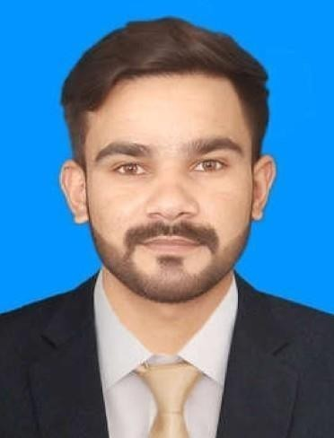

OBAIDASLAM

CONTACT

+92490132127

+923002820091

obaidaslam375@gmail.com Pakistan City zaman Park kot sheikhupura

PERSONALDETAILS

Date ofBirth 16/07/199 Nationality - Pakistani Gender - Male martial Status- Single PassportNo - HCO843251

LANGUAGES

English Hindi Urdu Panjabi

WORKEXPERIENCE

**LabHelperTechnician Pakistan**

1. Year

**ITHAM college 1 yr of Hospitality of tourism Hotel management diploma 1 yr experience from Lexus Grand hotel**

1. Years

EDUCATION

**I.Com**

3rdDivision(2019

BoardofIntermediateEducationLahore,Punjab

**SSC**

Board ofIntermediate&Secondary Education,Lahore, Punjab

COMPUTERKNOWLEDGE

**MSOffice**

(MSWord,MSExcel.power point) internet

PERSONALSKILLS

DedicatedandHardworking

Abilitytoworkindividuallyandateammember

Goaloriented,determined,strongwilledandselfmotivated Flexible and swift learner

Welldevelopinterpersonalandcommunicationskill Able to work overtimeat short notice if required. Abilitytoquicklyidentifyand resolveproblems.

Declaration

I assure to serve your organization to the best of myability and state the facts stated by me in these documents are true to the best of my knowledge and beliefs.

**OBAIDASLAM**