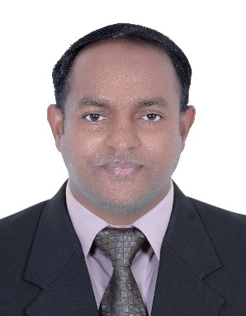

### SKILLS

* Good communication skill
* Good leadership quality
* Strong presentation abilities
* Employee Motivation
* Excellent team player
* Focused
* Computer skill( MS office)
* Emails & Internet

### Education

**Higher Secondary**

Board of Higher Secondary Examination Kerala- India

### Hobbies

* Nationality : Indian
* Date of Birth : 20-05-1984
* Marital Status : Married
* Visa Status : Visit Visa
* Passport No : Y6700745
* Expiry Date : 15-07-2033
* Languages Known : English-Tamil

Hindi-Malayalam

### REFRENCE

* Upon request

To be a qualified as Office Support Clerk, Administrator and Office Coordinator whose expansive knowledge in the areas of Staff Management, Clerical section, Front and Back office administration can contribute to organizational development

**AREA OF INTREST: HR COORDINATOR - OFFICE COORDINATOR - PHARAMCY ASSISTANT**

### Experience

2016 -2023

**OFFICE COORDINATOR**

QD_CPC INDUSTRIES W.L.L- QATAR

* Follow office workflow procedures to ensure maximum efficiency
* Maintain files and records with effective filing systems
* Support other teams with various administrative tasks (redirecting calls, disseminating correspondence, scheduling meetings etc.)
* Greet and assist visitors when they arrive at the office
* Monitor office expenditures and handle all office contracts (rent, service etc.)
* Perform basic bookkeeping activities and update the accounting system
* Deal with customer complaints or issues
* Monitor office supplies inventory and place orders
* Assist in vendor relationship management

**2013-2015**

**OFFICE BOY**

QD_CPC INDUSTRIES W.L.L- QATAR

* Serve Tea and Coffee to Staff and office Visitor.
* Clean office kitchen on daily basis.
* Responsible for disposal of trash, waste, and other disposable material.
* Monitoring the use of equipment and supplies within the office.
* Dealing with queries or requests from the visitors and employees.
* Other everyday duties include collecting information, faxing and scanning, making copies and data entry

Vineesh AjanurKadapuram

**OFFICE CORDINATOR**

+971543628212

[vineesh18735@gmail.com](mailto:Vineesh18735@gmail.com)