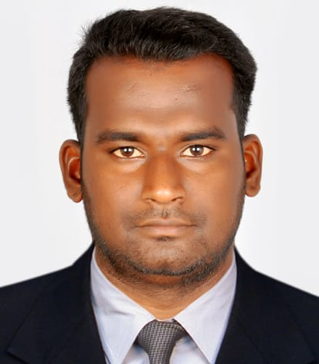

**PROFILE:**

Dedicated and enthusiastic professional with over 4 years’ experience within field of Store Management as in-charge, Primary Team handling and Logistics Management, Expertise in managing store operations, maintaining the company standards and Vendor customer coordination.

**S.PRABHU**

**CONTACT:**

phone.PNGphone.PNG

**EXPERIENCE:**

+971 528050793 prabhusraj205396@gmail.com

mail.PNG

**Team Leader**

➢ Handling team members,Monitoring CCTV

➢ Regularly update reports with Head office,

➢ Assigns guards to patrol and inspect of buildings and grounds,

➢ Monitoring security systems and responds to alarms, reports of issues, or requests for assistance.

mail.PNG

Industrial Area 12,

Sharjah,

United Arab Emirates.

2022-Till date

**Lahej & Sultan Cleaning Services & General Maintenance Co**,

AL Gharhoud, Dubai.

**TECHNICAL SKILLS:**

**Store Manager**

➢ Handling the complete store management and warehouse facility,

➢ Receiving, checking, recording, organizing,storing stock as it is received, PO,GRN,FIFO,Packing,labeling.

➢ I will continue update the Material inward and outward planning for the 15 branches stores,

➢ I will refuse to accept damaged,unacceptable or faulty items,

➢ I will identify slow moving item to avoid over purchasing,

➢ Taking inventories of stock and products, ensuring that they are safely and properly stored.

➢ Microsoft Excel,

➢ SAP,

➢ Word,

➢ Power point presentation,

➢ Billing software work experience,

➢ Email Customer communication through email Handling.

2017-2021 (4 year’s)

**Thalappakatti Hotel pvt Ltd**,

Dindigul, India.

**CORE COMPETENCIES:**

➢ Logistics Management,

➢ Customer –coordination,

➢ Warehouse Management,

➢ Inventory Management,

➢ Vendor Management.



**EDUCATION:**

2013 – 2017: **B.E Civil Engineering – 62.2 %**

(Indra Ganesan College of Engineering, Trichy)

2011 – 2013 : **Higher Secondary Education – 66%**

(Loyola Higher Secondary School, Dindigul)

**PERSONAL DETAILS:**

**DECLARATION:**

I do hereby declare that the particulars of information and facts stated herein above are true, correct and complete to the best of my knowledge and belief.

Date of Birth : 05/03/1996

Gender : Male

Nationality : Indian

Language : English, Tamil

Marital Status : Married

(S.PRABHU)

**Signature**