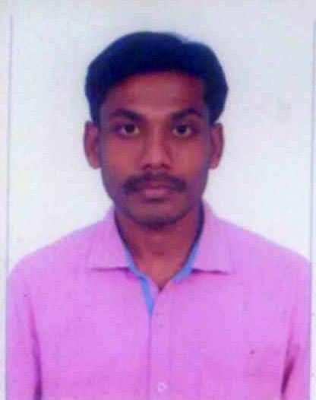 **PRAVIN KUMAR M**

1/205, school street,

Mangudi, Thiruvarur(TK) 610103

Mob: +96567740098

[Pravin4689@gmail.com](mailto:Pravin4689@gmail.com)

**Summary**

* Excel at coordinating tasks of numerous internal divisions and external agencies to ensure rapid, accurate delivery of equipment, materials, and resources. Advanced expertise in reviewing invoices and shipping manifests to ensure full compliance with local customs and international regulations. Track record of identifying redundancies and maximizing resources to streamline operations. Proficient in a variety of logistics and supply management software, both proprietary and commercial.
* Extensive experience in Creating E-Books, Journals using XML
* Ability to Learn new Technologies
* Good knowledge of quality processes
* Strong analytical skills

**Professional Experience**

* Around 2 years of experience in Logistic in SMSA EXPRESS.
* Around 2 years of experience in Xml Coding.
* Around 1 year of experience in station observer and cashier in KNPC LM Department .

## TECHINAL SKILLS

Markup Languages : XML, HTML, XHTML & CSS.

Tools : Epsilon, Oxygen and Altova.

Operating System : Window XP, 7 and 8.

Packages : Microsoft Office & Adobe Suites.

## Employment Details

* SMSA transportation, Saudi Arabia, from July-2017 to still working.
* Luminos Infocom, Chennai, India, from Feb-2013 to August-2015.
* KNPC LM DEPARTMENT, Kuwait from Apr-2022 - still working.

## Educational Qualification

* Diploma in Information Technology at R.V Polytechnic college Sembodai. Passed out on 2008.
* Secondary School Leaving Certification, Government Higher Secondary School. Passed Out on 2004.

## Roles and Responsibilities

**At KNPC:**

**Responsibility:**

* Full maintenance of petrol station
* Issued work permit for maintenance workers.
* Cash and customer handling.
* Have valid work permit and Gas testing authorized card.

**At SMSA :**

**Responsibility:**

* Sorting, scanning and data entry for Inward and Outward details.
* Supply Chain Portal Handling, scanning and data entry for Inward and Outward details.
* Transportation / Materials Handling.
* Coordinated with staff regarding relocation and transportation arrangements. Prepared documentation and coordinated transport of resources and materials. Marked and labeled freight; documented, verified, and inventoried cargo; and prepared and submitted report documentation. Maintained accurate records and managed office correspondence.

**At Luminos Infocom:**

**Responsibility:**

* Providing the company with required software and hardware needs.
* Have a good knowledge in Windows working environment.
* Installation of required software applications and hardware devices.

## Personal Information

* DOB: 04-JUN-1989.
* Permanent Address: 1/205, School Street, Mangudi, Thiruvarur. Tamil Nadu. India. PIN-610103.
* Have a valid passport to work at foreign countries.

I hereby declare that the particulars of information and facts stated here in above are true, correct and complete to the best of my knowledge and belief

**Place** : **India.** **Signature**

## Date :

**(M.PRAVINKUMAR)**