**CURRICULUM VITAE**

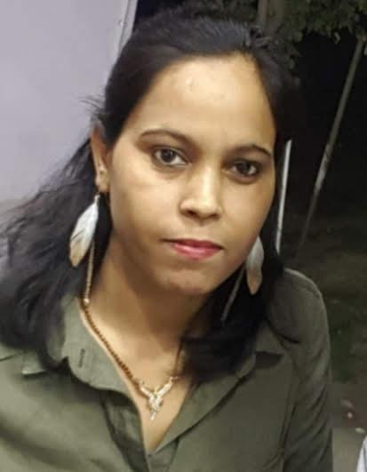

* **Uttam Nagar New Delhi-59**

**Contact no:- +91-8368348274**

**Passport No.: -** **W2554536**

**Email- Roopa.singh@hotmail.com**

**ROOPA RANI**

**________________________________________________________________________**

* **Career Objective**

**Extremely motivated to constantly develop my skills and grow professionally. I am confident in my ability to come up with interesting ideas for unforgettable marketing campaigns. To pursue a challenging and professionally satisfying career and to sustain growth and to provide leadership for high level of process-based teamwork and commitment at all levels. To be creative and innovative and contribute to the resources. To be involved in the job, as much as to enjoy it.**

**______________________________________________________________________________**

* **Working Experience & Job Skills:-**
* Currently working as a **Sr. Sales Advisor** with **H&M** **(*Hennes & Mauritz*)** at Connaught Place New Delhi Since 5th October 2015 to till now.
  + **Role & Responsibility: -**
* Assisting shoppers to find the goods and products they are looking for
* Being responsible for processing cash and card payments.
* Stocking shelves with merchandise
* Giving advice and guidance on product selection to customers
* Dealing with customer refunds.
* Responsible dealing with customer complaints
* Working within established guidelines, particularly with brands
* Attaching price tags to merchandise on the shop floor.
* Keeping up to date with special promotions and putting up displays and helping Visual.
* Effectively handling the Inventories of the store, ensuring the stock is refilled in timely manner working on the slow and the fast mover and acting on the same.
* Worked with **DFS** ( Duty Free Shop ) as a **Sr. Sales Associate** at IGI Airport From June **2013**  to Feb. **2015**
  + **Role & Responsibility: -**
* Interactions with customers for resolving inquiries, receiving payments by cash, credit cards, or through checks on a daily basis.
* Responsible for welcoming customers on getting into the organization and giving them information about products and services
* Involve neatly bagging or wrapping each of the customer’s purchases.
* Ensure honesty and error free handling of cash.
* At the end of the working period for the day, counting the money in the cash register and compare it with transaction records in the computer

.

* Worked with Marks & Spencer as a **Sales Associate** at DLF Saket From Aug. **2010** to May **2012**.
  + **Role & Responsibility: -**
* Assisting & redressing the customer's queries.
* Updating stocks and sales reports.
* Ensuring maintenance of V.M standard.
* Taking customer's feedback about the service and store.
* Achieve the sale and loyalty target
* Worked with Adidas as a **Sales Associate** at DLF Saket From April **2009** to July **2010**
  + **Role & Responsibility: -**
* Responsible for the Sales of the store, achieving the Daily, Weekly & Monthly target.
* Analyzing the Fast and the slow-moving products and working on them accordingly.
* Managing the day-to-day activity of the store
* Effective & Attractive Visual Merchandising of Products.
* Provide and maintain high level of Customer service and Customer Satisfaction
* **Educational Qualifications:**

|  |  |  |
| --- | --- | --- |
| Degree | School / University | Year Of Passing |
| B. A | Miranda House Delhi University | 2008 |
| HSC | Modern Vidya Mandir Sr. Sec School Faridabad | 2005 |
| SSC | Modern Vidya Mandir Sr. Sec School Faridabad | 2003 |

* **Achievements & Key Skills: -**
* Employee of the month 2 time in marks & spencer
* Star Performer in the team
* Communication skills
* Consulting skills
* Punctual
* Self-discipline
* Positive thinker
* Ability to handle any types of people
* Some fabric knowledge and also have a costumer convince Power
* **Technical Skills:**
* Basic Knowledge of Computer
* **Hobbies:**
* Cooking
* **Personal Details:**
* Date of birth : 25th May 1988
* Gender : Female
* Marital status : Married
* Languages known : English & Hindi
* Passport No. : W2554536
* **Declaration:**
* I hereby declare that the information submitted is true to the best of my knowledge and belief.
* PLACE:…
* DATE:.....

Sign..

**Roopa**