**CARRIER OBJECTIVE**

RASHEED IBRAHIM

Personal Details

Name

Rasheed Ibrahim

**Email Address**

[**Rasheed_ibrahim785@yahoo.com**](mailto:Rasheed_ibrahim785@yahoo.com)

**Contact No**

**+923002236869**

**+923462738656**

**Home Address**

**H/No A-10 Al Falah Housing Society Malir Halt Karachi,Pakistan 7400**

Date Of Birth

**27th August 1985**

**Sex**

**Male**

**Country**

**Pakistan**

* 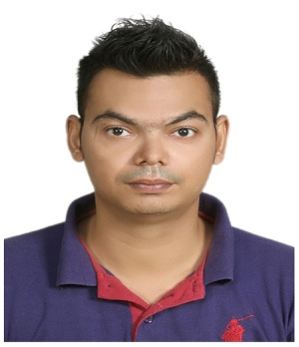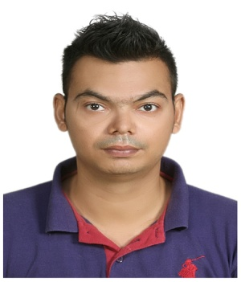Indent to get a position to utilize my skills and abilities into practice for mutual growth and benefit and make endeavors to words the way which innovative.

**PERSONAL INFORMATION**

* Father Name Syed Ibrahim
* Date of Birth 27th August 1985
* Marital Status Married
* Nationality Pakistani
* N.I.C No 42201-6657840-9
* Passport No AD5178403
* Religion Muslim

**EDUCATION**

* 2007 – 2009 Bachelors Degree - Bachelors of Commerce From University of Karachi ,Pakistan

**KEY SKILLS**

This is the main summary of my skills

* MS Office 2010 ( MS Word , MS Excel , MS Power point , MS Access , Outlook Express )
* Windows Operating ( Windows 8 , Windows 8.1 & Windows 10

**Languages**

Good Communication Skills

* English ( Good )
* Urdu ( Fluent )

**Personal Traits**

* Good analyzing abilities
* Good leadership abilities
* Good abilities to perform in multi- tasking work group
* Want to grow with the organization

**PROFESSIONAL EXPERIENCE**

* April 2013 To Dec 2016

Jindal Saw Gulf LLC Iron Duct Pipe Manufacturing Company Abu Dhabi, UAE

(Designation)

As an Assistant Dispatch

( PPC & Logistics Department )

Job Description

Full time role overseeing the operation of the PPC & Logistics Department.

* Successfully Perform managerial duties during manager’s absence
* Train new employees and conduct company and iron duct pipe orientations
* Documents control ling & monitoring to all our pipe loading and cheek quality before dispatching
* Monitoring the warehouse check update the quantity of All Sizes of gas git and lubricant