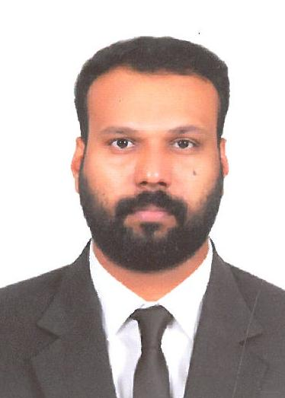

RAVI RAJ. HD

Phone: 0527251036 / 0544790961

Email: ravirajhd14@gmail.com

Address: Bur Dubai – U.A.E

|  |  |  |
| --- | --- | --- |
|  | Objective |  |
|  |  |

To seeking a challenge assignment & responsibility, with an opportunity for growth and career advancement and earn a job which provide me job satisfaction & self-development, help me to achieve personal as well as organization goal while being involved in work where I can utilize skills, creativity, effectively contributes to the growth of organization to gain experience as well.

|  |  |  |
| --- | --- | --- |
|  | Experience |  |
|  |  |

Organization : Spinney’s Dubai, Dubai – U.A.E

Designation : Baker

Duration : 2013 to till now

**DUTIES & RESPONSIBILITIES:**

* Mixed all ingredients and baked bread dough in the oven, as per recipes.
* Shaped, decorated, and packaged all loaves of freshly prepared bread.
* Baked and delivered a variety of breads for all types of occasions.
* Operated and cleaned all cutting tools and kitchen appliances, properly.
* Assigns specific tasks to each member of the baking team.
* Qualifies suppliers of baking materials for the Spinney’s
* Conducts secondary audit on store and kitchen inventory.
* Conceptualizes new cake designs and recipes for the Spinney’s
* Followed Bakery Production Chart and prepared all required quantities of baked products, on time.
* Produced, labeled, dated, and displayed all bakery products, properly.
* Stored, rotated, and restocked all ingredients and food supplies, to prevent wastage and shortage.
* Cleaned and maintained bakery carts, food stations, and related equipments.
* Followed proper food handling procedures and complied with safety standards.

|  |  |  |
| --- | --- | --- |
|  | Key Skills |  |
|  |  |
| Professional   * Presentation style * Trust building * Basic Computer knowledge * Internet browsing & Email | Strengths   * Communication Skills * Quick learner * Decision making skills * Positive Attitude * Strong Work Ethics | Personal   * Outgoing personality * Confident speaker * Results oriented * Time management * Passionate |

|  |  |  |
| --- | --- | --- |
|  | Education |  |
|  |  |

* H.S.E Passed board of Higher Secondary Education Kerala Govt. St. India

|  |  |  |
| --- | --- | --- |
|  | Training |  |
|  |  |

* Customer Service Training Phase-2 from Spinneys, Dubai
* HSE (Health and Safety Environment) from Spinneys, Dubai
* Certificate in HACCP Level-1&2 from Spinneys, Dubai
* Certificate in Basic Food Hygiene from Spinneys, Dubai

|  |  |  |
| --- | --- | --- |
|  | Personal information |  |
|  |  |

* Date OF Birth : 25/04/1984
* Nationality : Indian
* Passport No : L2799564
* Religion : Hindu
* Gender : Male
* Languages known : English, Hindi, Kannada & Malayalam
* Marital status : Married
* Visa status : Employment Visa

|  |  |  |
| --- | --- | --- |
|  | Declaration |  |
|  |  |

I hereby declare that the particulars furnished above are true to the best of my Knowledge and belief.

Raviraj .HD