JERRY GARCIA

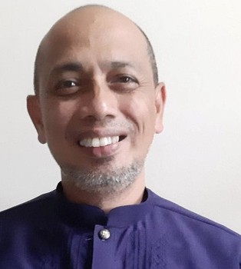

Budget Management

About Me

"Driven by passion, guided by expertise, and committed to excellence."

+639217376576



[brgytalaga4003@gmail.com](mailto:brgytalaga4003@gmail.com) 070 Purok 1 Brgy.Talaga



Rizal Laguna, Philippines 4003

LANGUAGE

English Filipino

EXPERIENCE

**SEARCH ENGINE OPTIMIZATION (SEO)**

# AJT EVENTS MANAGEMENT

## Rizal Laguna

November 30, 2023 – February 1, 2024

Market Research

Assisting in conducting market analysis and industry trends

Conduct thorough keyword research to identify valuable research

Analyze keyword competitiveness and search volume.

Develop keyword strategies to drive targeted traffic.

# **BARANGAY TREASURER**

# Local Government Unit (Barangay)

## Rizal Laguna (LGU)

July 2, 2018 - November 20, 2023

Keep custody of Barangay Funds and properties.

Manage and maintain accurate records of all financial transactions, including taxes, fees, contributions, and other revenue sources accruing to the Barangay

In-charge of procurement

# **SWIMMING INSTRUCTOR/POOL MAINTENANCE**

## Blazing Shark Swim Team _ Rizal Laguna February 2, 2016 - March 12, 2018

To Develop a new Breed of Swimmers

To motivate new swimmers in competitive thinking to teach new students the proper way/stroke of swimming

Maintain the Cleanliness of the pool and water quality

EXPERTISE

EDUCATION

Financial Management Taxation and Revenue Collection

Record Keeping and Reporting Negotiation

Ethics and Integrity Leadership

## Southern Luzon Polytechnic Collage

Bachelor of Arts in Psychology 1990 - 1991

## Systems Technology Institute

Computer Programming 1991- 1993

SKILLS SUMMARY

Budget Management Leadership

85%

81 %



AWARDS AND ACHIEVEMENT

Department of Information and Communication Technology General Virtual Assistant Scholar -

Department of Budget and Management - Philbo - Calabarzon Seminar Workshop on R.A 9184 - Government Procurement Act

Commission on Audit Barangay Financial Management

University of the Philippines Disaster Reduction and Management in Health Center

Basic Emergency Response Team Simulation Training

Philippines Red Cross Laguna Chapter

Standard First Aid and Basic Life Support