RESUME

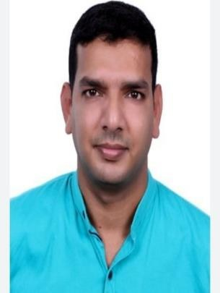

**PRASHOBH .P.C**

**PRASANNA VIHAR MYLADATHADAM ROAD AZHIKODE.PO. KANNUR-670009 KERALA STATE**

**INDIA**

**PHONE:+91 8089540219**

Email: [prashobh5386@gmail.com](mailto:prashobh5386@gmail.com) PASSPORT NO:T1258180

# OBJECTIVE :

To apply constant learning and innovative techniques in the field of accounts, inventory and finance for a career, which is challenging and also rewarding.

# EDUCATIONALQUALIFICATION :

* **DEGREE IN BACHELOR OF COMMERCE AT KANNUR UNIVERCITY**
* **PLUS TWO at KPRGS GHSS KALLIASSERI**
* **S.S.L.C. at Azhikode High School at Kannur.**

# COMPUTER SKILL SETS :

* **MS Office**
* **Internet Applications**
* **Computerized Financial Accounting**

# WORK EXPERIENCE :

* + **Worked as an accountant for 3 years in HAR CARS - KANNUR,**
    - **Mainly Vehicle invoicing ,**
    - **Spare bill entries**
    - **Cheque payments of Co dealers**
    - **Payments of customer cheques , etc…..**
  + **Worked as an Assistant Accountant in PHOENIX CARS INDIA PVT LTD**
  + **worked as an assistant accountant in Sales Tax Consultancy Centre**
  + **Worked as an Accountant in KUNNUMPURATH TRADERS – ALAVIL**
  + **Worked as an Accountant in FOCUS SUPER MARKET - AZHIKODE**
  + **Worked as an Accountant in NIKSHAN ELECTRONICS - KANNUR**
  + **Working as an Security Guard in ORION SECURITY SERVICES LLC**

**- DUBAI**

# MAJOR RESPONSIBILITY :

* **Control over all accounting and financial matters.**
* **Handling maintaining account up to finalization**
* **Preparation of year ending schedules and account for audit**
* **Managing accounts receivable and payables**
* **Reconciliation of Bank, Debtors, and Creditors AREA OF INTEREST :**
* **Accounts**
* **Computer Operation**
* **Communicating with Everyone**

# STRENGTHS :

* **Friendly**
* **Committed**
* **Sincere**
* **Patient and Ambitious**
* **Confident to face any challenges**

# TYPE OF EMPLOYMENT DESIRED :

Ready to work in any firms and in any levels with the strength of my qualification and my sincere work experience.

# PERSONAL PROFILE :

Name : PRASHOBH.P.C

Father’s Name : S/O BALAKRISHNAN NAIR Date of Birth : 22-01-1987

Marital Status : MARRIED Sex : MALE

Nationality : Indian

Language Proficiency : English,Hindi &Malayalam.

Visa Status : No Visa

# DECLARATION

I hereby declare that all the details and particulars furnished above are correct to the best of my knowledge.

**PRASHOBH . P. C KERALA-INDIA**