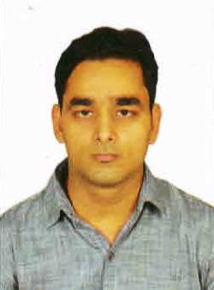
RESUME

ANAND KUMAR
Address : H.NO-10 Chamunda Enclave
Albatiya Shahganj Agra- 282010
Contact No.: + 919410086728 ,
Email Id : anandchelwani@yahoo.in , anandchelwani@gmail.com

To reach heights of success in my profession where it provides me constant learning experience and leads to my intellectual growth while enhancing my leadership qualities and ability to work in team.”

ACADEMIC QUALIFICATION
- High School from U.P.Board

EXPERIENCE
- 5 Years Working Experience in Shoe Wholesale Market Agra (20 July 2007 To 20 July 2012) .
- 3 Years Working Experience as a Salesman in Mars Hypermarket (Shoes Section) Muscat (oman) (27 July 2012 To 24 Aug 2015).
- 2 years working experience in building material company daksh build mart Gambia (West Africa) as a salesman (3 june 2016 To 25 feb. 2018)
- 2 year working experience in super market Martinez hermanos company (guinea equatorial) (central Africa) As a incharge supervisor (4 feb. 2019 To 28 jan. 2021

PERSONAL PROFILE
- Father’s name : Late.Shri Narendra Kumar
- Date of Birth : 05 Oct 1985
- Gender : Male
- Nationality : Indian
- Languages Known : English, Hindi , Sindhi
- Marital Status : Unmarried
- Weight : 70 Kg
- Height : 5.7

DECLARATION
In the end I may assure you that if am given a chance I shall try my best to satisfy all the concerned with my work.
Place: Agra
Date
{ANAND KUMAR}

