CURRICULUM VITAE

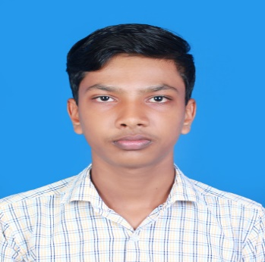

**MUHAMMED RIYAS A.A**

**OUNGATTIL HOUSE | PATTITHARA | OTHALUR POST |**

**PALAKKAD | 678613 |** [**rriyas5609@gmail.com**](mailto:rriyas5609@gmail.com%20) **| 9048515364**

### To start my career with an organization where I could add value to the organization for the mutual success by using my technical knowledge and skills

**OBJECTIVE**

* Creative and proactive candidate with **ONE YEAR** of practical experience in Networking & System Administration
* A skillful, dynamic and multitalented person with a professional course in **COMPUTER HARDWARE, MCSE, RHCE, CCNA, CCTV, LAPTOP CHIPLEVEL ENGINEERING & SECURITY SYSTEMS**

**SYNOPSIS**

* Assembling, Configuring and Troubleshooting Desktops and Laptops
* Troubleshooting operating system failure and OS repairing

**PRACTICAL EXPOSURE**

* Optimizing hardware performance and operating system performance
* Configuring and Troubleshooting Workgroup and Domain network, File sharing
* Installing, Configuring and Troubleshooting local and network printers
* Designing Network infrastructure
* Network Cabling and crimping of UTP cables
* Installing and Configuring Microsoft Server (2016/2019) &Client operating Systems
* Configuring Server roles and features
* Deploying and Configuring Dynamic Host Configuration Protocol (DHCP)
* Deploying and Configuring Domain Name System (DNS)
* Installing and Configuring Internet information Services (IIS)
* Deploying Active Directory Domain Service(ADDS)
* Installing and Configuring Red Hat Enterprise Linux 7
* Deploying and Configuring RHEL7 server roles and clients
* Managing Cisco Routers and Switches
* Cisco Router interface configuration and troubleshooting
* Configuring LAN Routing, WAN routing , Static Routing
* Configuring and Managing Dynamic Routing Protocols (OSPF,EIGRP,BGP)
* Configuring Switches, VLAN, Inter Vlan Routing, STP
* Cisco IOS installation, updation, Backup , Disaster recovery
* Deploying security and Access Control Lists
* Configuring Network Address Translation (NAT)
* Deploying Wireless networks (AP. SSID, WEP, WPA)
* Installing and configuring CCTV, DVR, NVR, IP Camera

✓ Installing and configuring Security systems, Biometrics and Fire alarm system

# OTHER SKILLS

## GRAPHIC DESIGNING AND VIDEO&SOUND EDITING

**Software Included:** Photoshop, illustrator, CorelDraw, InDesign, PageMaker, Adobe Premier, After Effects, Sound forge, Edius

## WEB DESIGNING

**Software Included:** Html, CSS, Bootstrap, Dream Weaver, JavaScript, JQuery

## OFFICE AND ACCOUNTS MANAGEMENT

**Software Included:** Microsoft Office, Tally, Peachtree

# TRAINING: CORPORATE MANAGEMENT AND MARKETING

### Key Areas:

* Marketing
* Office management
* Customer handling
* Telephone and email etiquettes

# PERSONAL INFORMATION:

FATHER’S NAME NATIONALITY

DATE OF BIRTH

GENDER

RELIGION

MARITAL STATUS

LANGUAGES KNOWN

HOBBIES

:

:

:

:

:

:

:

:

:

ABOOBACKER

INDIAN

22-02-2002

MALE

MUSLIM

SINGLE

MALAYALAM, TAMIL, AND ENGLISH

READING

**DECLARATION**

**I hereby declare that the above information is true to the best of my knowledge.**

**PLACE: PALAKKAD YOURS TRULY**

**DATE:** MUHAMMED RIYAS A.A