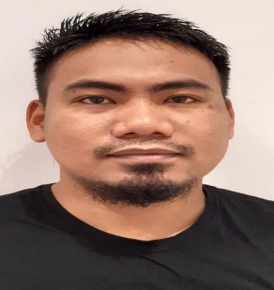**ROLANDOREGALACUBE**

**Objective:** Seeking employment that allows me to grow and being able to utilize my skills for the betterment of the organization with the best use of my dedication, determination and resourcefulness.

# PERSONALINFORMATION

|  |  |  |  |
| --- | --- | --- | --- |
| Address  Date of Birth | : : | **Al Satwa Dubai UAE**  **May 1, 1990** | |
| Nationality | : | **Filipino** | |
| Gender | : | **Male** | |
| Visa Status | : | **Cancelled Employment visa** | |
| UAE License No. | : | **4325606 (Light Vehicle)** | |
| Contact No. | : | **050-590-8553** | |
| Availability | : | **Immediately** | |
| Email Address  **EDUCATION** | : | **regalacube01@gmail.com** | |
| **Isabela State University** Echague, Isabela, Philippines Course:  **EMPLOYMENTHISTORY** | | **Bachelor of Science in Criminology** | |
| **November 15, 2023- November 30, 2024**  Position :  Company :  Address : | | **Family Driver**  Mohammad Abdulla Ali Al Gergawi (Employer)  48st villa 25 Al Khawaneej Dubai, UAE | |
| ***April 2018- September 2023*** |  |  |
| ***Position*** | : | **Villa Caretaker cum Family Driver** |
| ***Company*** | ***:*** | Abolfazi Ansari (Employer) |
| ***Address*** | ***:*** | The Palm Jumeirah, Dubai |

## DUTIES, RESPONSIBILITIES & JOB DESCRIPTIONS

* Responsible in maintaining the garden by regular removing off the weeds and watering the plants.
* Responsible in cleaning the interior area of the villa such as the kitchen, living room, bathrooms, guest rooms and gym area regularly.
* Responsible in buying the grocery supplies in a regular basis when the family spends their vacation in the villa as well as driving them to wherever they request to go.

***Apr 2014- Sept 2018***

***Position*** : **Delivery Driver (URC, Jack n Jill Products)**

***Company :*** Dimaya Group of Companies

***Address :*** San Isidro, Isabela, Philippines

## DUTIES, RESPONSIBILITIES & JOB DESCRIPTIONS

* Deliver a wide variety of items to different addresses and through different best routes.
* Follow best routes and time schedule.
* Responsible in supervising product loading & unloading
* Responsible in preparing and inspecting the delivery vehicle.
* Ask for feedback on provided services and resolve clients' complaints.
* Collect cash payments & issue invoices.

***Sept 2011- March 2014***

***Position*** : **Merchandiser (Johnson Products)**

***Company :* Saver’s King Echague branch**

Echague, Isabela, Philippines

**Farmacia Navarro**

Santiago, Isabela, Philippines

## DUTIES, RESPONSIBILITIES & JOB DESCRIPTIONS

* Performs other related duties as assigned.
* Maximize customer interest and sales levels by displaying products in corresponding shelves appropriately.
* Maintain inventory by restocking shelves with corresponding products, observing inventory levels, prompting store management to reorder when levels appears low and arranging for return and credit for damaged products
* Transfers supplies and equipment between storage and work areas by hand or cart.
* Monitor stock movement and consider markdowns; promotion price changes, clear outs etc.
* Flexibility to respond to a range of different work situations.

# PERSONALQUALIFICATIONS

* Good organization skills
* Demonstrates the ability to interact with the public and coworkers in a friendly, enthusiastic and outgoing manner
* Ability to bend, twist, and stand to perform normal job functions
* Good communication skills
* Excellent grooming standards
* Ability to work a variety of shifts
* Ability to work on my own or in group