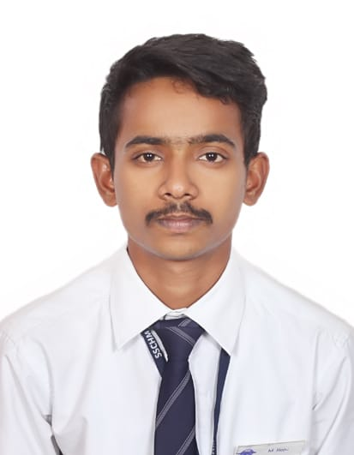 |  | R A J U M A N G A L A R A P U  Operations manager  Profile  Dynamic and results-driven operations manager with over 1 years of experience in optimizing business operations for efficiency and profitability. Proven track record of leading cross-functional teams, implementing process improvements, and driving operational excellence. Skilled in strategic planning, resource allocation, and performance optimization to achieve organizational goals. Adept at fostering a collaborative work environment and cultivating strong relationships with stakeholders to drive business success
Personal details  Raju Mangalarapu  S/O Damodhar  Dubai, United Arab Emirates  On Visit Visa  DOB: 6th June 2000  Contact  PHONE & WHATS APP :  +971569033853  EMAIL:  Rajtony21@gmail.com  HOBBIES  Listening Music  Playing chess  Cooking  ACHIVEMENTS  English fluency test (Negatives) in 2014  English Fluency Test (AV Structure with Nouns) in 2014 |  | EDUCATION  Bachelor of Hotel Management and Catering Technology Shri Shakti College of Hotel Management 2019-2022  Intermediate Trinity Junior College 2017-2019  Secondary School Certificate Oxford High School 2016-2017  WORK EXPERIENCE  November 2022 – December 2023 Operations Manager | Domino’s | Hyderabad  Lead and oversee day-to-day operations, including production, logistics, and supply chain management, to ensure smooth and efficient workflow. Develop and implement strategic plans to optimize operational processes, reduce costs, and increase productivity. Collaborate with cross-functional teams to identify areas for improvement and implement solutions to enhance efficiency and performance. Manage budgeting and resource allocation to meet operational targets while minimizing expenses.  SKILLS  Operations Management  Strategic Planning  Process Improvement  Team Leadership  Performance Optimization  Budgeting and Resource Allocation
Languages known
English
Hindi
Telugu (mother tongue)

