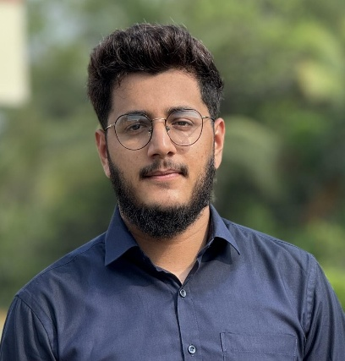**Rabie A. Rehaman**

Dubai, United Arab Emirates

LinkedIn: (<http://www.linkedin.com/in/rabie-rehaman-kazi-399b26285>)

Email: [rabie.ark@gmail.com](mailto:rabie.ark@gmail.com)

Phone: +971568897886

**Career Objective:**

Dynamic and results-oriented Business Administration graduate with a strong foundation in analytical skills and project management. Seeking a challenging role in a progressive organization to apply academic knowledge and professional experience. Committed to contributing to operational efficiencies and organizational success through strategic problem-solving and effective project execution.

**Education:**

**Institute of Company Secretaries of India (ICSI)**

* Executive Level – Pursuing
* Foundation Level – Completed 2023

**Mangalore University, India**

* Bachelor of Business Administration, 2023

**Work Experience:**

**Baba Abbas Trading, India February 2024 – May 2024**

**Cashier cum Accountant,**

* Managed daily cash transactions and balanced cash registers with accuracy.
* Handled accounts receivable and payable and ensuring timely payments
* Prepared financial reports and statements for management review.

**Greet Technologies, India**  **September 2023 – December 2023**

**Sales and Customer Service Representative,**

* Managed customer inquiries and resolved issues promptly to ensure satisfaction.
* Achieved sales targets by effectively promoting products and services.
* Collaborated with team members to enhance customer experience and streamline processes.

**Internship Experience:**

**Infinity Electric Vehicles, India** **June 2023 – July 2023**

**College Project Intern**

* Assisted in analyzing market trends and preparing reports for management.
* Supported project managers in planning and executing marketing campaigns.
* Collaborated with cross-functional teams to streamline internal communication processes.

**Skills & Interests:**

* **Analytical Skills:** Proficient in data analysis for informed decision-making.
* **Project Management:** Skilled in planning, executing, and closing projects.
* **Communication:** Excellent written and verbal communication abilities.
* **Technical Proficiency:** Proficient in Microsoft Office Suite (Word, Excel, PowerPoint) and familiar with Tally ERP accounting software.
* **Team Collaboration:** Demonstrated ability to work effectively in team environments.
* **Time Management:** Strong organizational and multitasking abilities.

**Leadership and Activities:**

**College Management Fest, Bhandarkars College, Mangalore University, India 2023**

* Led a team of 15 members to organize an inter-college management fest.
* Managed budgets and secured sponsorships from external stakeholders.
* Awarded “Best CEO” at the management fest.

**Volunteer, Community Service**

* Organized and participated in community outreach events supporting elderly individuals.

**Personal Details**:

* **Languages:** English, Hindi
* **Date of Birth:** 23 March 2002
* **Visa status: Residence visa**