

**Mian Syed Raza Shah** 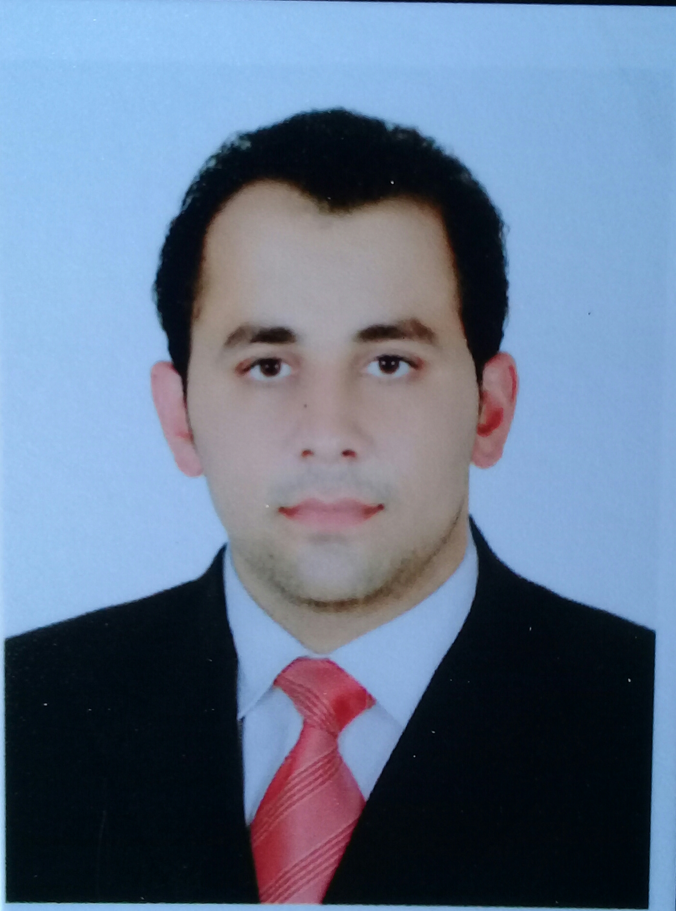

**Permanent Address:** Vill Shalbandi, P.O Daggar, Teh/ Gagra Distt Buner.

**Mobile #:** +92-347-9354309   
**Email:** itxraza309@gmail.com

|  |
| --- |
| **OBJECTIVES:** |



 Seeking a challenging opportunity in an organization with highly competitive and

demanding environment where I can exploit my knowledge and skill with full spirit.

|  |
| --- |
| **CAREER OBJECTIVE:** |

 For the entrance to the post professional life to apply in an Organization productivity

and profitability and thus resulting on my personal and professional growth.

|  |
| --- |
| **PERSONAL INFORMATION:** |



* Father’s Name : Mian Syed Jehan
* Date of Birth : January,12-1990
* N.I.C No : 15101-5791213-9
* Passport # : DE5172131
* Marital Status : Married
* Domicile : Khyber Pukhtoonkhwah
* Nationality : Pakistani

|  |  |  |  |
| --- | --- | --- | --- |
| **ACADEMIC QUALIFICATION:** | | | |
| **Degree** | **Year** | **Div** | **Board** | |
| Master in English ( Final) | 2020 |  | Continued | |
| Master in English (Previous) | 2019 | 2nd | University of Swat KPK Pakistan | |
| Bachelor of Elective English | 2018 | 2nd | University of Swat KPK Pakistan | |
| F.A | 2008 | 2nd | BISE Swat KPK Pakistan | |
| SSC | 2006 | 1st | Oriental Public School Buner KPK Pakistan | |

|  |
| --- |
| **MAJOR SUBJECTS:** |



* History of English literature and poetry
* English literaturere & linguistics

|  |
| --- |
| **PROFESSIONAL Education:** |



* I.T certificate from Alfalah college of technical education KPk Pakistan.
* Certificate in Ms. Office , software installation from Expert institute of Computer science Karachi Pakistan.
* Certificate in Networking, Data communication and hardware from Alfalah college of technical education KPK Pakistan.
* Also trained from (PSMA) US Aid in psychosocial support and teaching methodology.



|  |
| --- |
| **Hobbies:** |



* Reading Newspapers, Novels
* Watching movies
* Listening music
* Playing Cricket

|  |
| --- |
| **Languages:** |



* English
* Arabic
* Urdu
* Poshto

|  |
| --- |
| **References:** |



* Available on request

|  |
| --- |
| **Major Subjects:** |



Fundamental concepts of computer system, Data communication, Computer-

Hardware, Business communication, Introduction to operating system such as

MS DOS, Linux, UNIX and NT file system.

|  |
| --- |
| **Technical skills and Tools:** |



* Can work in JDA system over B2B platform as DSD receiving, returns to vendor, Transfers management, and Negative adjustment for ghost stock.
* Auto replenishment
* Point of sale (POS) troubleshooting
* Getting SKUs# & Barcodes information by using software named BO (Back office)
* Software installation
* Checking hardware problems and enabling them to work
* Microsoft Office

|  |
| --- |
| **Work experience:** |



* Worked for 4 years in retail sales and operations dept as a data encoder using “JDA” B2B (Business to Business) platform and a software named “Back office” in AlOthaim markets company K.S.A from July 2012 to March 2016.
* Worked as a data entry operator in Alkhair public High school & college for

three years as well as worked on hardware checking, replacing and enabling

them to operate.

* Well gained 5 years experience in teaching English courses in high schools.