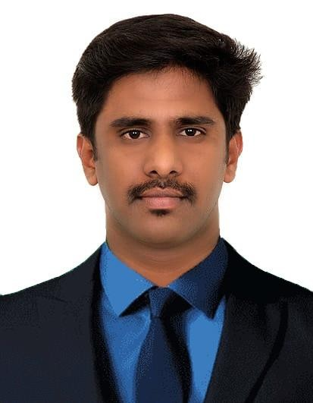

RENUKAVIYA G

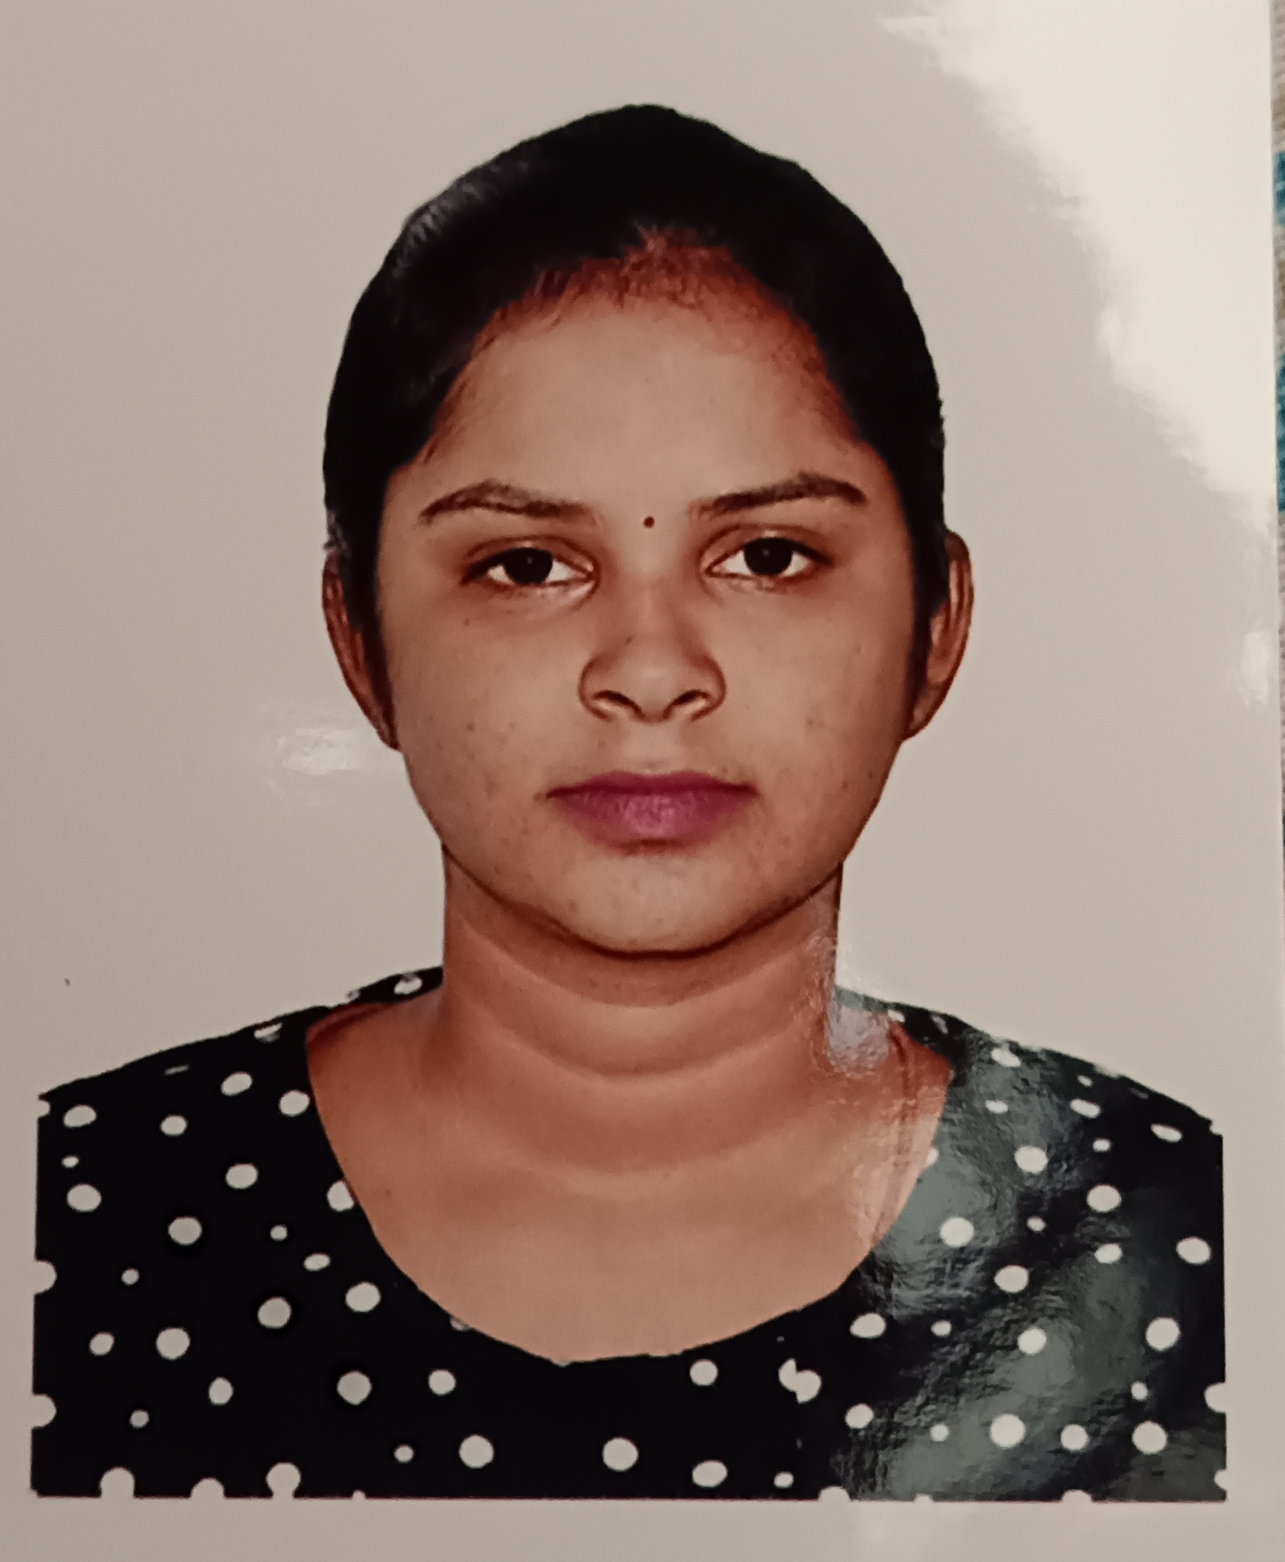

# 

# Contact

## Address:

202 Hatta Building, Deira, Dubai.

## Phone:

+971556374874

## Email:

[renukaviya07@gmail.com](mailto:renukaviya07@gmail.com)

# Languages

Tamil – Native Language

English – Can Write & Speak

# Hobbies

* Reading Novels,Pencil Drawing
* Cooking

# Skills & Experience

1 Year of experience in Play School,India

# Area of Interest

|  |  |
| --- | --- |
| * Microsoft Office * Play school |  |

Summary

To Make use of my interpersonal skills to achieve goals of a company that focus on customer satisfaction and customer experience and secure a responsible career opportunity to fully utilize my training and skills, while making a significant contribution to the success of the company.

# Education

Higher Studies: **Computer Science**

Saraswathi Vidyalaya Higher Secondary School, Madurai-2019

# Personal Details

Date of birth : 03 Nov, 2000.

Passport No : W4589501.

Nationality : Indian.

Religion : Hindu.

Marital Status : Married.

Visa Status : Visit Visa Until June 10,2023

# Declaration

I hereby declare that the above-mentioned information is correct up to my knowledge and I bear the responsibility for the correctness of the above -mentioned particulars.

## Place: Al Rigga,UAE Renukaviya G