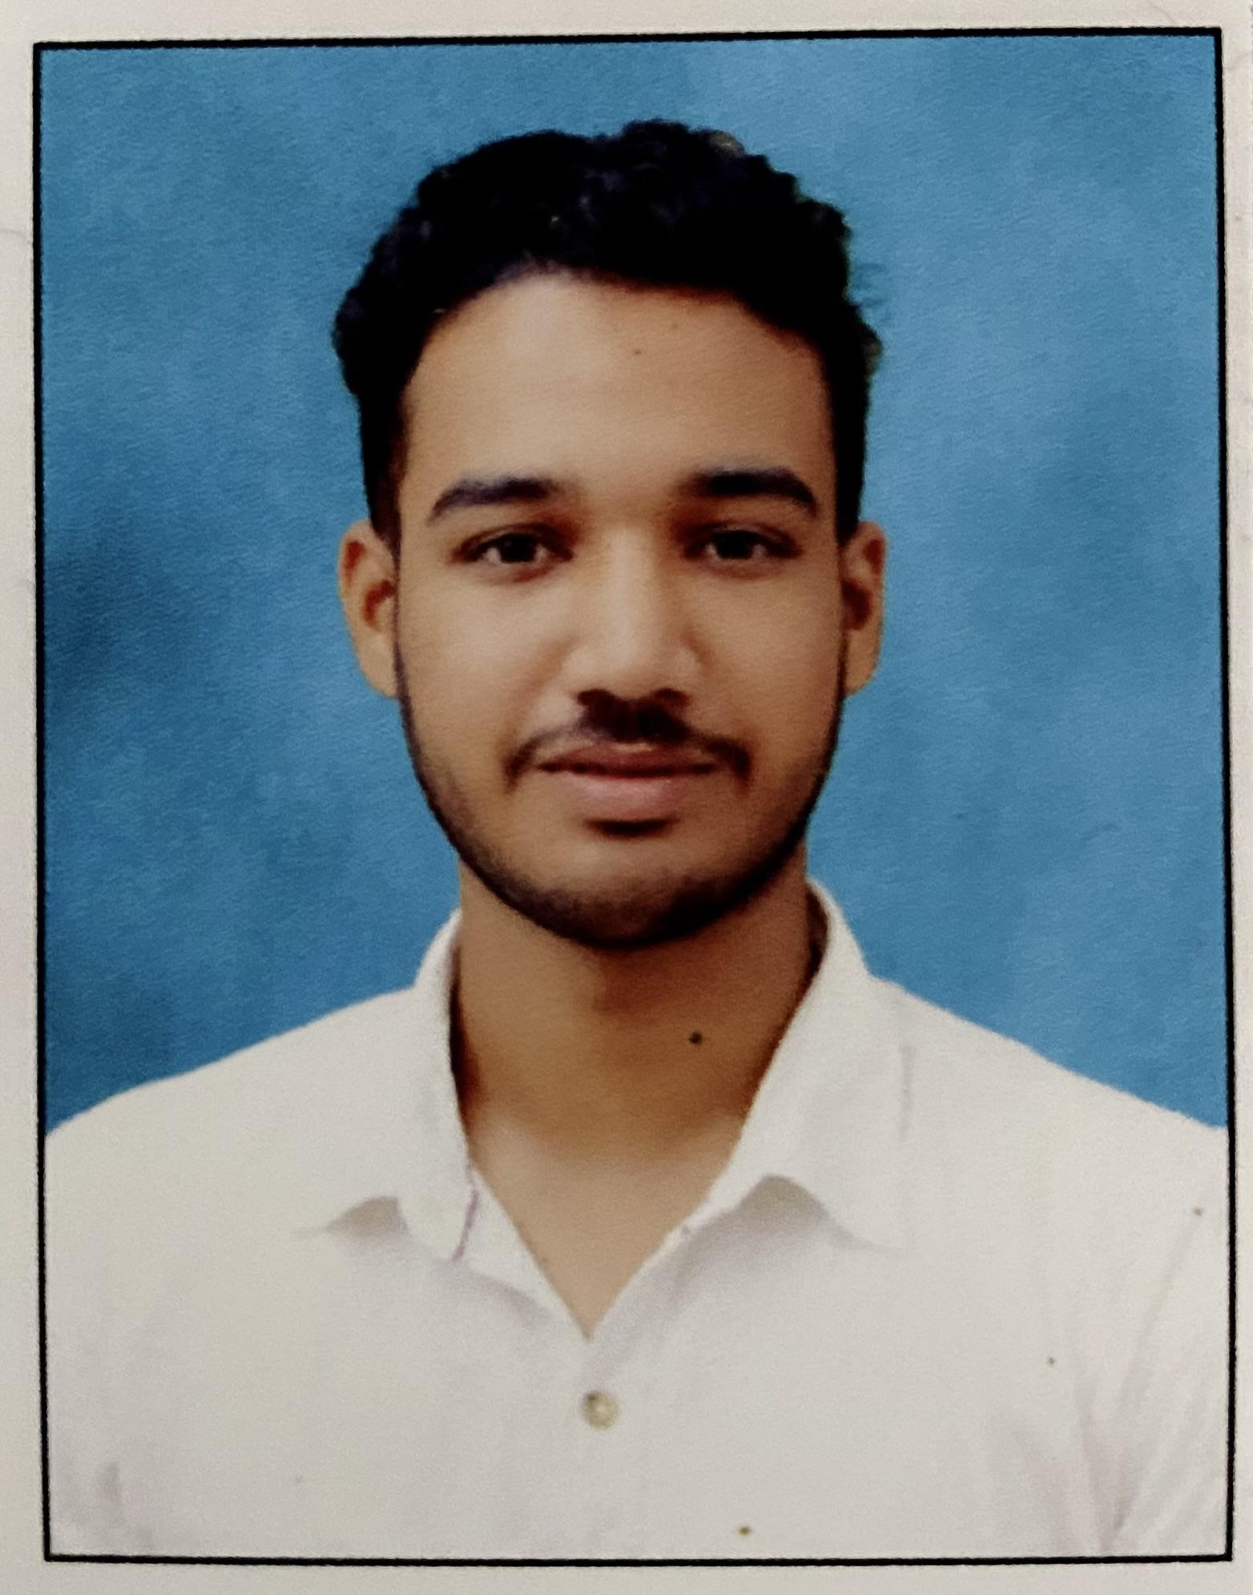 |  | abubakkar siddeeq
Profile  Performed basic mathematics, Experienced cashier with more than three years of experience assisting customers in the check-out process. Awarded “Employee of the Year” in both 2022 and 2023. Seeking a cashier role at RETAIL, where my service skills and friendly personality can be leveraged to achieve the highest quality of service at your establishment.  Contact  PHONE:  8197933118  EMAIL:  siddeeqabubakker65@gmail.com  Skills  Handling  Conflict management  Fluency in language  Customer service  Cash and card transactions  Excellent memory  Computer skills  Microsoft office skills  Creativity skills |  | EDUCATION  Ghps School Yermal  Scored 84.48% in 10th  2018-2019  Participating in cultural programs  Govt PU Collage Kanyana  Scored 64% 11th  2019-2020  Voted as college students leader  WORK EXPERIENCE  Kabab Mehak cashier & customer support  01/07/20–01/08/23  - Analyze business and report accurate details.  - Value customer and resolve their quires.  - Back office analze.  - Handled customer requests and complaints professionally and escalated to manager when necessary  - Provided courteous, friendly, and speedy service to customers, ensuring any concerns they had regarding product prices, sales, and inventory issues were quickly resolved  - Managed and personally responsible for avg. of $500 during shift in cashier drawer  langauge  English  Hindi  Arabic (read,basic speak)  Kannada  Malayalam

