APPLICATION FOR JOB

To: HR Department

Dear Sir / Madam

I introduce myself as a professional Graduate with relevant experience.

I have almost 12 years of working experience in the UAE and 4 years in Oman.

I strongly believe that my knowledge of the subject and attitude would enable me to learn and grow with the job in your organization. I also believe that I have a great deal to offer your company and that I have the ability and determination to perform well in position you would offer me.

On giving me an opportunity, I assure you that I shall make it my earnest endeavor to discharge sincerely and competently the duties entrusted to me.

Thanking You

Sincerely Yours

Abdul Sathar.
Kannur,Kerala
0091 7510187124

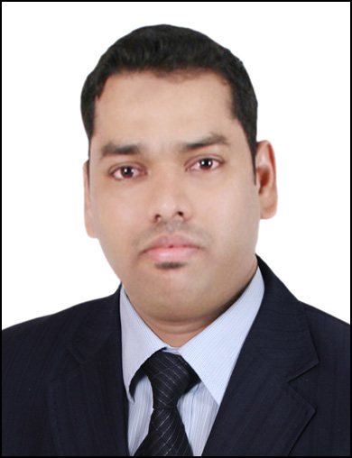

ABDUL SATHAR. KP
Dubai : Mb: 0097155 39727 96
0091 7510187124
E-mail: abdulsath1981@gmail.com

Profile

Experienced and self motivated Graduate from a reputed university, looking for challenging work opportunities to prove my skills and use my professional experience to the optimum and be part of an organization having excellent goodwill. At the same time, to reach my personal goals

Career Objective

Wish to work with your organization with the hope of getting an opportunity to prove myself by utilizing my skills, knowledge, professional experience, methods and ways to benefit to the organization in all the possible ways.

Professional Work Experience

- Worked as Branch Manager at Makkah Hyper Market , Oman.
- Worked as Supervisor at Al Rostamani International Exchange, Abudhabi, UAE.
- Worked as Admin Assistant at Paris Group International L. L. C Dubai.
- Worked as Customer Care Manager at Indus Motors Pvt Ltd Co, Calicut, Kerala.

Branch Manager (2019-2023)

Worked as Branch Manager at Makkah Hyper Market, Oman.It has been in to the retail business for the last 25 years.makkah Hyper Market is the one of the oldest brand in Oman.

Major Job Responsibilities
- Overseeing pricing and stock control.
- Ensure the highest standard of Customers satisfaction through excellent service.
- Adhere to Front Office procedures and controls at all times.
- Preparing promotional materials and displays.
- Maximizing profitability and setting /meeting sales targets.
- Set goals for performance and deadlines in ways that comply with company’s plans and vision and communicate them to subordinates.
- Organize workflow and ensure that employees understand their duties or delegated tasks.
- Monitor employee productivity provide constructive feedback and coaching.
- Receive complaints and resolve problems.
- Maintain Statistical and financial records.
- Pass on information from upper management to employees and vice versa.
- Prepare and submit performance reports.
- Decide on reward and promotion based on performance.
- Ensure adherence to legal and company policies and procedures and undertake disciplinary actions if the need arises.

Branch Supervisor (2014-2018)

Worked as Supervisor with AL Rostamani International Exchange, Abudhabi as Supervisor, and leading exchange company in UAE with their wide branch network and business in the areas Corporate & Retail wire transfers, WPS processing, Currency Exchange etc.

Major Job Responsibilities
- Supervise the staff and branch operations in the absence of a Branch Manager and perform the Branch Manager duties as required.
- Ensure the highest standard of Customer Service is given at all times.
- Adhere to Front Office procedures and controls at all times.
- Ensure that the company Anti-Money Laundering policies and procedures are strictly adhered.
- Balancing the cash at the end of the day and preparing the necessary reports and correctly entering the transaction data into the system.
- Set goals for performance and deadlines in ways that comply with company’s plans and vision and communicate them to subordinates.
- Organize workflow and ensure that employees understand their duties or delegated tasks.
- Monitor employee productivity provide constructive feedback and coaching.
- Receive complaints and resolve problems.
- Maintain timekeeping and personnel records.
- Pass on information from upper management to employees and vice versa.
- Prepare and submit performance reports.
- Decide on reward and promotion based on performance.
- Ensure adherence to legal and company policies and procedures and undertake disciplinary actions if the need arises.

Admin Assistant (2007-2014)

Worked as Admin Assistant with Paris Group International L.L.C, Dubai, UAE as well established company in dealer of well known brands of Men and Ladies Fashion like Versace, Canali, Gianfranco Ferre,Pierre Cardin, Tedlapidus, Azzaro and Verri.

Major Job Responsibilities
- Assist in the administering with updated relevant set of Human Resource Policies and systems.
- Develops and maintains a human resources system that meets top management information needs.
- Assign and monitor clerical, administrative and secretarial responsibilities and tasks among staffs.
- Coordinate office staff activities to ensure maximum efficiency.
- Prepare operational reports and schedules to ensure efficiency
- Plans new employee orientation to foster positive attitude toward Company goals.
- Provide professional executive and administrative support to the Sales and Marketing Department.
- Motivate the subordinates.
- Implement procedural and policy changes to improve operational efficiency.
- Responsible for the management of the day to day work of the Office.

Customer Care Manager (2005-2007)

Worked as Customer Care Manager at Indus Motors Pvt Ltd Co, Calicut, Kerala.

Major Job Responsibilities
- To Maintain Records of Customers.
- To understand the satisfaction of customers.
- To motivate the subordinates.
- To take corrective decision for customer satisfaction.
- To conduct promotional events.

Skills and Competencies:
- Ability to work varied hours/days, including nights, weekends, and holidays, as needed.
- Excellent English written and oral communication skills.
- Ability to handle complete assignment independently.
- Result oriented, initiative & hardworking.
- Well versed with MS Word, MS Excel and internet tool.
- Good Public relation.
Communication Skills

Effective and efficient Writing, Oral, and Listening Skills in

- English
- Hindi
- Arabic
- Malayalam

Professional Qualification

- Qualification : Master of Business Administration ( MBA)
- University : Kannur University
- Year : 2003-2005

Personal Profile

Father's Name : Ibrahim
Date of Birth : 14-05-1981
Sex : Male
Nationality : Indian
Religion : Islam
Marital Status : Married

Declaration

I
I hereby declare that the above mentioned information is true to the best my knowledge and belief.

Yours faithfully, ABDUL SATHAR KP
00971 55 397 27 96
0091 75 101 87124

