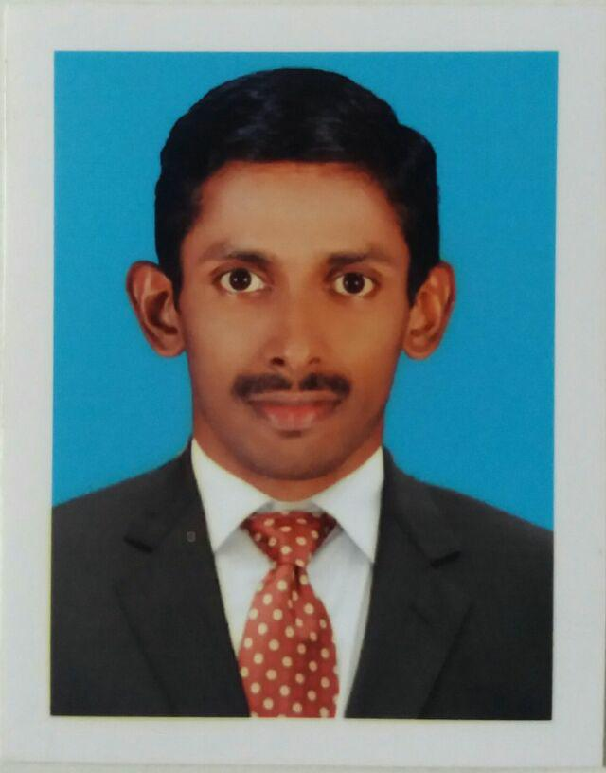  RESUME | Sheril.K.B
 | shrlkb38@gmail.com
 | 8078151412

CAREER OBJECTIVE

To associate with an organisation which progress dynamically and give chance to Update my knowledge and skill for the growth of the organisation

WORK EXPERIENCE

Jan-2008 - Till Today Impulse

Divisional manager Recruiting candidates and providing training in marketing and

management and Checking performance of the team and helping them to improve their prformance

EDUCATION DETAILS

Degree/Course | Year of Passing
Bachelor of Business Administration | 2008
Pazhassi Raja Callege , Calicut University
PGDCA | 2008
Cyber Computer Education , Private

AREAS OF INTEREST

Business,management,administration,marketing,any challenging job which give growth personally along with company growth.
HOBBY

Watching Movies,songs,Surfing internet

PERSONAL DETAIL

Address Kallerimattathil house,veliyambam post.

Pulpally,wayanad (District), Kerala, 673579

Passport detail G5238339

Date of Birth 09.06.1984

Gender Male

Nationality India

Marital Status Married

Languages Known Tamil, English

DECLARATION

I here by declare that above mentioned Information is true to the best of my knowledge and belief


Sheril.K.B

