5

Objective

Seeking a suitable position in Food Safety/Hygiene or Quality control and Microbial testing departments of healthcare settings as well as Industries that allows me to use my skills and abilities to enhance and grow with the company that offers competitive and professional environment

Summary

Bachelors Degree in Microbiology with modest work experience in Food safety & Hygiene departments which overseeing food production and supply activities

Skills in implementing plans to correct non-compliance of food safety protocols and handling food safety tests according to set rules.

Demonstrated experience in developing HACCP quality management systems to ensure food safety and quality assurance to ensure the highest level of accountability.

Experience

Hygiene officer , IMC Catering Co.,Doha,Qatar.

* Implement a series of food safety evaluations, resulting in 100% compliance with internal food safety procedures

* Conduct food safety and compliance inspections on a regular basis to determine if all safety protocols are being adhered to
* Perform inspections of food handlers to ensure that sanitation, handling, temperatures and equipment
* Develop and implement sanitation programs and provide workers with information on good food handling practices

Food Safety & Hygiene Supervisor (Voluntary)

Al Ahli Hospital, Doha, Qatar.

* Set and comply the food safety norms at all levels of operations starting from goods receipt till Serving is in line with the local laws and regulations and International standards [ISO 2200, RvA, HACCP, RSPH etc.]
* Investigate hygiene & food safety complaints from guests & staffs and make immediate corrections and verify that preventive action taken is in order to avoid repetition
* Provide In-house Training to all the catering staffs, food attendants in regard to food hygiene, personal hygiene, food handling and sanitation
* Carry out random in-house and Supplier hygiene audits throughout the operation and take corrective action whenever necessary

**Vidya Sajith**

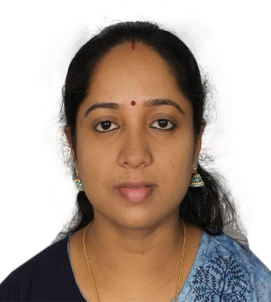

**Microbiologist**

Building 45, Street 220

Zone 91

Al Wukair, Qatar.

 +974 50573288  +974 33818627

**[](mailto:npsajith@gmail.com)** Vidya.jayakrishnan@gmail.com

**Core Competancies & Skills**

Level 3 Certification in Supervising HACCP for Catering by HABC/ UK.

Food Safety Evaluations

Compliance Investigation and regulation

Quality Control

Operations Auditing

Process Improvement

**Languages**

English

Hindi

Malayalam

Trainee Microbiologist, Badagara Co-operative Hospital Ltd., Vatakara, India.

Trainee Microbiologist, Department of Laboratory Medicine, Malabar Institute of Medical Sciences Hospital (MIMS), Calicut, India.

Education

2005: B.Sc. Microbiology, Kannur University, Kerala, India. 67%

2002: HSC (Intermediate) Directorate of Higher secondary Education, Government of Kerala, India.58%.

2000: SSLC (Std.10th) Board of General Education, Kerala, India. 79%

Personal Profile

Age & Date of birth : 37 Years. 29/05/1985

Nationality : Indian

Marital Status : Married

Passport No. : T2434689

Date of Expiry: 19.02.2029

Visa Status : Valid Resident Permit- Qatar

(Family Sponsorship)

RP Expiry: 19/11/2023

References’

Up on Request

Personal Skills

Detail-oriented and organized

Ability to learn & Adapt

Good Communication and Interpersonal skills

Certifications

HACCP Level 3 Certification in Supervising for Catering by HABC/ UK

Project work

Studies on the incidents of pathogenic bacterias in frozen foods with special reference to Vibrio Cholerae & Vibrio parahaemolyticus

Computer Skills

Microsoft word 2016

Microsoft Excel 2016