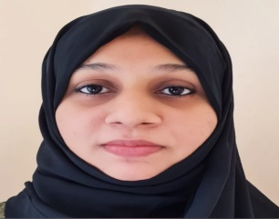 ZAHIRA ZUBAIR

**Contact:** +97156 6309246**, E-mail:** [zahirazubair24@gmail.com](mailto:zahirazubair24@gmail.com)

**Nationality:** Indian**, Address:** Sharjah, United Arab Emirates.

|  |
| --- |
| JUNIOR ACCOUNTANT CUM HR ASSISTANT |
| Having earned a Bachelor of Commerce degree and a Master of Business Administration degree, I have more than one year of UAE experience out of more than two years of experience as a Junior Accountant. I can work under pressure, have good multi- tasking abilities, as well as excellent organizational and interpersonal skills. Currently residing in Sharjah looking for suitable jobs in the HR and Accounts Department. |

CAREER PROGRESSION

***Junior Accountant******(Work from Home****)* **January 2022 to Till Date**

***Noor Al Yathrib General Trading LLC, Deira, Dubai***

***Responsibilities:***

* Generating invoices and account statements.
* Preparing account reconciliations.
* Prepare ageing report and follow up for payments

***Junior Accountant Cum HR Assistant* May 2019 to June 2020**

***Dhofar Center, Kerala, India***

***Responsibilities:***

* Prepare invoice for daily rent for auditorium and monthly rent for shops.
* Collecting cash and deposit to bank.
* Make payments of utilities and other miscellaneous expenses.
* Scheduling appointments, answering phones, checking mails, greeting visitors, and maintaining organized file systems for the organization.

EDUCATION & CREDENTIALS

* Master of Business Administration (MBA) from Calicut University, Kerala, India **2010-2012**
* Bachelor of Commerce (BCOM) from Calicut University, Kerala, India **2007-2010**

SKILLS

* QuickBooks.
* Microsoft Office.
* Analytical and problem-solving skills.
* Organization and attention to detail.
* Time management.
* Effective communication.

PERSONAL

* Notice period: Join immediately.
* Visa Status: Husband Visa.
* Date of Birth: 24th August 1988.
* Marital Status: Married.