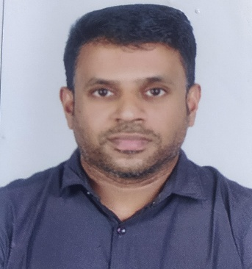

**AHEMMEDKUTTY AK**

Mobile: +971-556886347, 02-2025754

Email: ahemmedk@gmail.com/ahemmedk@yahoo.com

P.O.BOX: 4188-ADNOC OASIS 508 VIC MUROOR ABUDHABI, UAE

**Career Objective:**

To obtain the reasonable level of professional excellence working in a challenging and dynamic environment stimulating success, growth and value addition to the organization that I represent and serve, and to myself, while concurrently upgrading my skills and knowledge.

**Work Experience:**

**Total Work**

**Experience**: **Twelve Years**

1. This is Convenience Stores, more commonly known as C-Stores are getting visible in the UAE nowadays. These are small convenience store from fast food to toys, groceries, books and stationery items, chocolates, chips and more. Located in UAE

**ABUDHABI NATIONAL OIL COMPANY** *Start from Jun 2009 to Present*

**P.O. BOX: 4188 Abu Dhabi**

**United Arab Emirates**

# Duration: Since Jun 2009

Job Title: Cashier & Merchandiser

**From Jun 2009 to Handling Cashier & Merchandiser:-**

***Job Responsibilities:***

* Handling the cashier.
* Setting Selling Prices of All Products
* Checking Expiry of non Food & Food Items
* Receiving goods
* Make GRV Against Suppliers
* Give Order to The Supplier for goods
* Receiving goods from supplier
* Check all Quantity and pricing
* Daily Day end Process in cash Counter and Banking.
* Daily Deposit Cash in the Bank
* Daily Reporting the Head office about Seals and Banking.

2. One of The whole sale Dealer of Ply woods

**Fero Ply**   *Start from Feb, 2008 to Jun 2009*

**YMCA Calicut Kerala India**

**Job Title: Financial Accountant**

***Job Responsibilities***

* Handling of computerized Accounting up to finalization
* Handling of day to day Bank related works of the company
* Reconciliation of Bank statements and debtors A/c’s
* Preparation of Receivables & Payables Lists.
* Ensuring of monthly basis all accounts are reconciled and disputes are immediately highlighted and re-solved
* Preparation & submission of Financial Reports, over all control of Accounts.

3. One of the Whole sales Dealer of Floor & wall tiles and sanitary wares

**FERO PLY CALICUT*.*** *Start from April, 2006 to Feb 2008*

*KERALA INDIA*

**Job Title: Financial Accountant**

***Job Responsibilities***

* Creating a Purchase & sales Invoice,
* Handling receipt and payment Vouchers,
* Monitoring Customers Receivable List,
* Checking and accounting of Supplier Invoices
* Submitting Invoices with supporting documents.

**Professional Qualification:**

**School Leaving Certificate: March-1999**

**Higher Secondary Certificate: March-2001**

**IT SKILLS:**

**Computer Course**  DCA Diploma in computer Application

Computer college of India

Mukkom India

**Computer Course** Computer Financial Accounting

GIIT Calicut India

**Personal information:**

Full Name Ahemmedkutty AK

Date of Birth may 05, 1984

Nationality India

Marital Status Married

Father Name's Abudhabi

Passport Number E 4913959

Language Spoken (fluent) English, Arabic, Hindi and Malayalam

Language Writing (fluent) English, Hindi, Arabic and Malayalam

**Permanent Address:**

**AHEMMED KUTTY AK**

**THATHOOR MAVOOR VIA**

**CALICUT KERALA INDIA**

**DECLARATION:**

I hereby declare that all the information provide is true and correct to the best of my knowledge and belief.

**Ahemmed kutty**