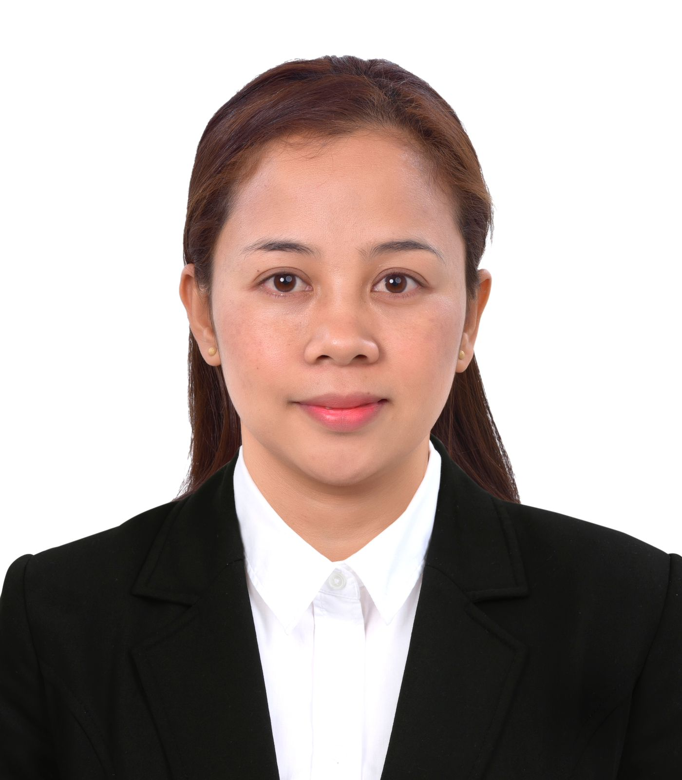

Summary

To obtain apposition that will fit my qualification and develop my skills as well as to contribute for the development of the company

Skill Highlights

|  |  |
| --- | --- |
| * time management * Strong decision maker * Complex problem solver * flexibility | * Team work * Interpersonal skills * Coustomer services * Communication skills |

Experience

* Working as a housekeeping at AL TAMNYAH SERVICES LLC (Dubai) since 10 November to tell date.(Registered housekeeper in Just Life cleaning Services)
* 1 Years Experience as housekeeping in home sweet home hospitality QATAR since OCT 2021 to 1 October 2023
* 2 Years 7 month Experience as cashier & cake decoration in Robinson mall Philippines since Jan 2019 to Aug 2021
* 2 Years 9 months Experience as sales staff in Buckwise Trading Corp Philippines since Jan 2016 to Oct 2018
* 1 Years 2 month Experience as sales & cashier at Trendee zone boutique Philippines since May 2014 to July 2015

Education

* **Assistant Nurse (CNA)4 month course Jan 2024 to May 2024**

**Newton Training Center Dubai.**

* **Secondary School 2008 to 2012** Enrequite Montila De Esteban Memorial high school
* **Tertiary 2013 to 2015** Carlos Hillado Memorial College Negros Occidental ComTech (Undergrad)

Personal Details

* Name Rodelie F.Habania (Khadeeja)
* Place of Birth Candoni Neg Occidental
* Gender Female
* Marital status Marred
* Religion Muslim
* Passport no P4592354B
* Passport iss 29 Jan 2020
* Passport Exp 28 jan 2030

RODELIE F.HABANIA

Contact

Nationality: phillipines

Date of birth: 10 OCT 1993

Gender: female

(+971)568348327

Email address: [Rliehabania@gmail.com](mailto:Rliehabania@gmail.com)

Languages

* Tagaloge
* English
* Arabic