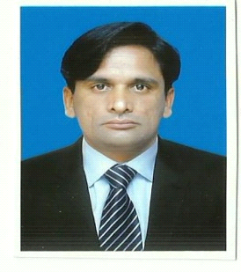**SAIF UR REHMAN**

**Address: Chak # 72/4R P/o Haroonabad, Bahawalnagar.**

**Cell No: 0300-4545430**

**Email:** [**saif1306r@gmail.com**](mailto:saif1306r@gmail.com)

**Career Objective:**

Keen to find a challenging position within an ambitious organization where I will be able to continue to increase my work experience & develop my abilities.

**Experience:**

**SINDH BANK LIMITED, PAKISTAN**

**Cashier 22 Jan 2016 to 20 Aug 2019**

* **Receipt Payment and sorting of cash**
* **Handling of Remittances i.e. Banker Cheque, On Line Clearing**
* **Utility Bills**
* **Account Opening**
* **ATM Replenishment**

**Computer Skills:**

**Microsoft Office (MS Word, Excel & MS Power Point) In page & Internet Search.**

**Key Skills:**

* **An extremely efficient, hardworking individual with a great level of commitment to further my career.**
* **An organized and systematic approach to my work resulting in deadlines and projects always being met to a high standard.**
* **Have the ability to work as a team player due to my approachable, friendly nature as well as having the knowledge and instinct to work with minimal supervision.**
* **Very strong computer skills including, Word, PowerPoint, Internet explorer & net browsing.**

**Education:**

**Graduation** (B.A) Islamia University Bahawalpur Pakistan

**HSSC** (F.A) Bahawalpur Pakistan

**Matric**  (Intermediate board of education Bahawalpur

**Personal Details:**

**Father Name: Sardar Ahmed**

**Nationality : Pakistani**

**Religion : Islam**

**N.I.C # 31104-5025250-3**

**Date of Birth: 15 June, 1983**

**Marital Status: Married**

**Domicile: Punjab**

**Language Proficiency:**

**Proficiency in written and spoken English, Urdu, Punjabi**

**Personal Interest**

**Playing Cricket and football Strong communication, customer**

**Reference:**

**Reference will provide on demand.**