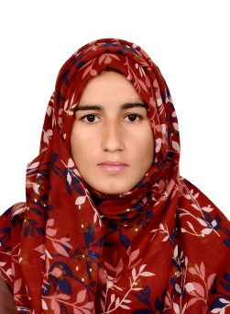

[saimashoukat243@gmail.com](mailto:saimashoukat243@gmail.com)

 +971 569531265



Dubai, United Arab Emirates

**Profile**

## A highly motivated and driven Person Confident, tenacious with a proven track record for account handling. A broad knowledge of a wide range of financial practices, including credit control, budget handling and forecasting. An excellent communicator with a can-do approach to problem solving and resolution. Extremely meticulous with an eye for detail and positive outlook in often complex financial landscapes.

**Education**

**Personal profile**

* Date of Birth : 15/02/2000
* Nationality : Pakistan
* Marital Status : Single
* Passport No : NT 5191661
* Passport Expiry : 13/09/2028
* Visa Status : Visit Visa
* Language: Urdu ,English , Punjabi ,

# TAHIR ELECTRONICS

# A well know electronic and solar system distributor In district. I worked here for two year as part time job to meet my education expenses

* + Public Dealing
  + Keeping record of sales
  + Preparation of salaries
  + Preparation of Budget
  + Procurement of Minor Items and Petty Cash Handling
  + Drafting letters & Emails to faculty and staﬀ members
  + Office Administration, Filing and Record Maintenance
  + Work well as Team Member & Independently
  + Sales and account management

# SKILLS

## MS Office

* Cash Handling

## Customer Care

* Cash Management

## Record Management

* Inbound and Outbound calls handling

**ACADEMIC QUALIFICATION**

* Bachelor of Science ( Associate Degree Program) The Islamia University Of Bahawalpur, Pakistan 2023
* Higher Secondary,(Faculty of Science) Board of Intermediate Secondary Bahawalpur Pakistan 2019
* Matric Board of Intermediate Secondary Education Bahawalpur, Pakistan 2017