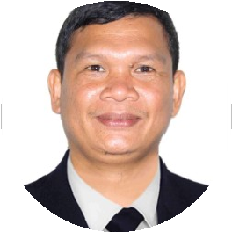

## Summary

A Licensed Professional Teacher with sixteen years of experience in education. Successfully facilitated communication between teachers, administrators, and parents. Exceptionally well-organized Office Administrator with expertise in meeting coordination, appointment scheduling, and administrative work management. Able to oversee several projects at once, guarantee work completion on time, and keep correct records.

Licensed Teacher seeking Office Admin Role

## Work history

**DISTRICT TEACHER COORDINATOR** – 04/2008 to 12/2023

**DEPARTMENT OF EDUCATION,** Sibuco, ZDN

* Evaluating and selecting applications from students
* Evaluating applications in light of our qualifying requirements
* Arranging and storing records

**ELECTION ASSISTANT** – 01/2007 to 08/2008

**COMMSSION ON ELECTION**,Sibuco, ZDN

* Carries out all administrative, clerical, and general office tasks, including data entry, transcribing, typing, record and file maintenance, and telephone reception.
* Necessitates knowledge of departmental operations and procedures in addition to a comprehension of the manager's job duties and working style.
* Keeps track of and arranges manager's records, correspondence, etc.

**Customer Service Representative** – 05/2005 to 12/2006

**GREENWICH PIZZA,** Zamboanga City

* Assisted customers with food selection, inquiries and order customization requests.
* Answered average of 100 calls per day, addressing customer inquiries, solving problems and providing new product information.
* Contacted customer to follow up on purchases, suggest new merchandise and inform on promotions and upcoming events.

SERHAN B. CERDENA

## Skills

* Detail-oriented
* Collaborative Mindset
* Exceptional communication skills
* Adaptability
* Quality assurance and control
* Team Management
* Exceptional communication skills

## Education

Master’s in Educational Administration

2009 – 2018

Bachelor in Elementary Education

2001-2005

## Language

English, Tagalog

0568146348

superhan4891@gmail.com

Dubai, UAE