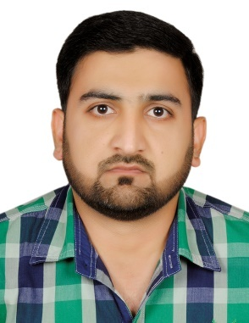***Shafiq Ur Rehman***

E-mail Id: [shafiq.rehman330@gmail.com](mailto:shafiq.rehman330@gmail.com), Contact #: **+971 526897303**

Address: AL Nahda, Sharjah, UAE

## **CAREEROBJECTIVES**

* To make a sound position in corporate world and work enthusiastically in team to achieve goal of the organization with devotion and hard work.
* To seek challenging assignment and responsibility, with an opportunity for growth and career advancement as successful achievements.
* To be involved in work where i can utilize skill and creatively involved with system that effectively contributes to the growth of organization.

## **WORK EXPERIENCE**

**BEST SHIPING LOGISTICS FZCO SEP** 2021 To still working

* Worked as cashier
* Accounts maintaining of the company
* Worked as a inventory controller
* Dealings with customers
* Worked as a Stock Controller
* Company sale dealing
* Follow up the customer and official emails

**Tcc Communication Dubai Airport Free Zone Jan** 2019 to March 2020

* Company Inventory handling
* Customer handling
* Stock handling of the company
* Receiving the shipments
* Dispatching handling of the customer

**City Pharmacy, Sharjah** April 2013 to Dec 2018

* Credit notes in charge
* Inventory controller
* Making goods receiving notes
* Stock handling
* Dealing with Customers and companies
* Handling goods return from market.
* Having good communication skills
* Follow up the emails.
* Working as a part of team
* Having good communication with people

### **Sami Pharmaceutical (Pakistan)**Mar 2012 —Mar 2013

#### **Medical Sales Officer**

Worked as medical sales officer in Sami Pharmaceutical in Pakistan

**EDUCATION**

### **B.com** June, 2007 —June, 2009

#### High aims college of commerce, Jauharabad (Pakistan)

## **GENERAL SERVICES**

* Integrity and high degree of professionalism.
* Dedication to work and high level of commitment with great team spirit.
* Attention to details with high level of accuracy and responsive.
* Able to handle time pressure, administrative and optimistic.
* Ability to prioritize, act and operate independently with minimal supervision.
* Good interpersonal skills and willingness to help another team will processing.
* Flexible with working hours if required.
* Ability to meet assigned deadlines.

## **PERSONAL DETAILS**

* Name: Shafiq Ur Rehman
* Father Name: Abdur Rehman Qazi
* Date of birth: 20Aug 1987
* Nationality/Religion: Pakistani/Muslim
* IT skills: Ms Office, Outlook, Internet surfing
* Language known: English, Urdu (Read, write, and speak very well)
* Interests / Hobbies: Meeting new people, Learning, Play Cricket, Watching movies.
* Sex/Marital status: Male/Married

## **DECLARATION**

I hereby declare that the above details are true and correct to the best of my knowledge. It would be.

Pleasure working in your firm.