***CURRICULUM VITAE***

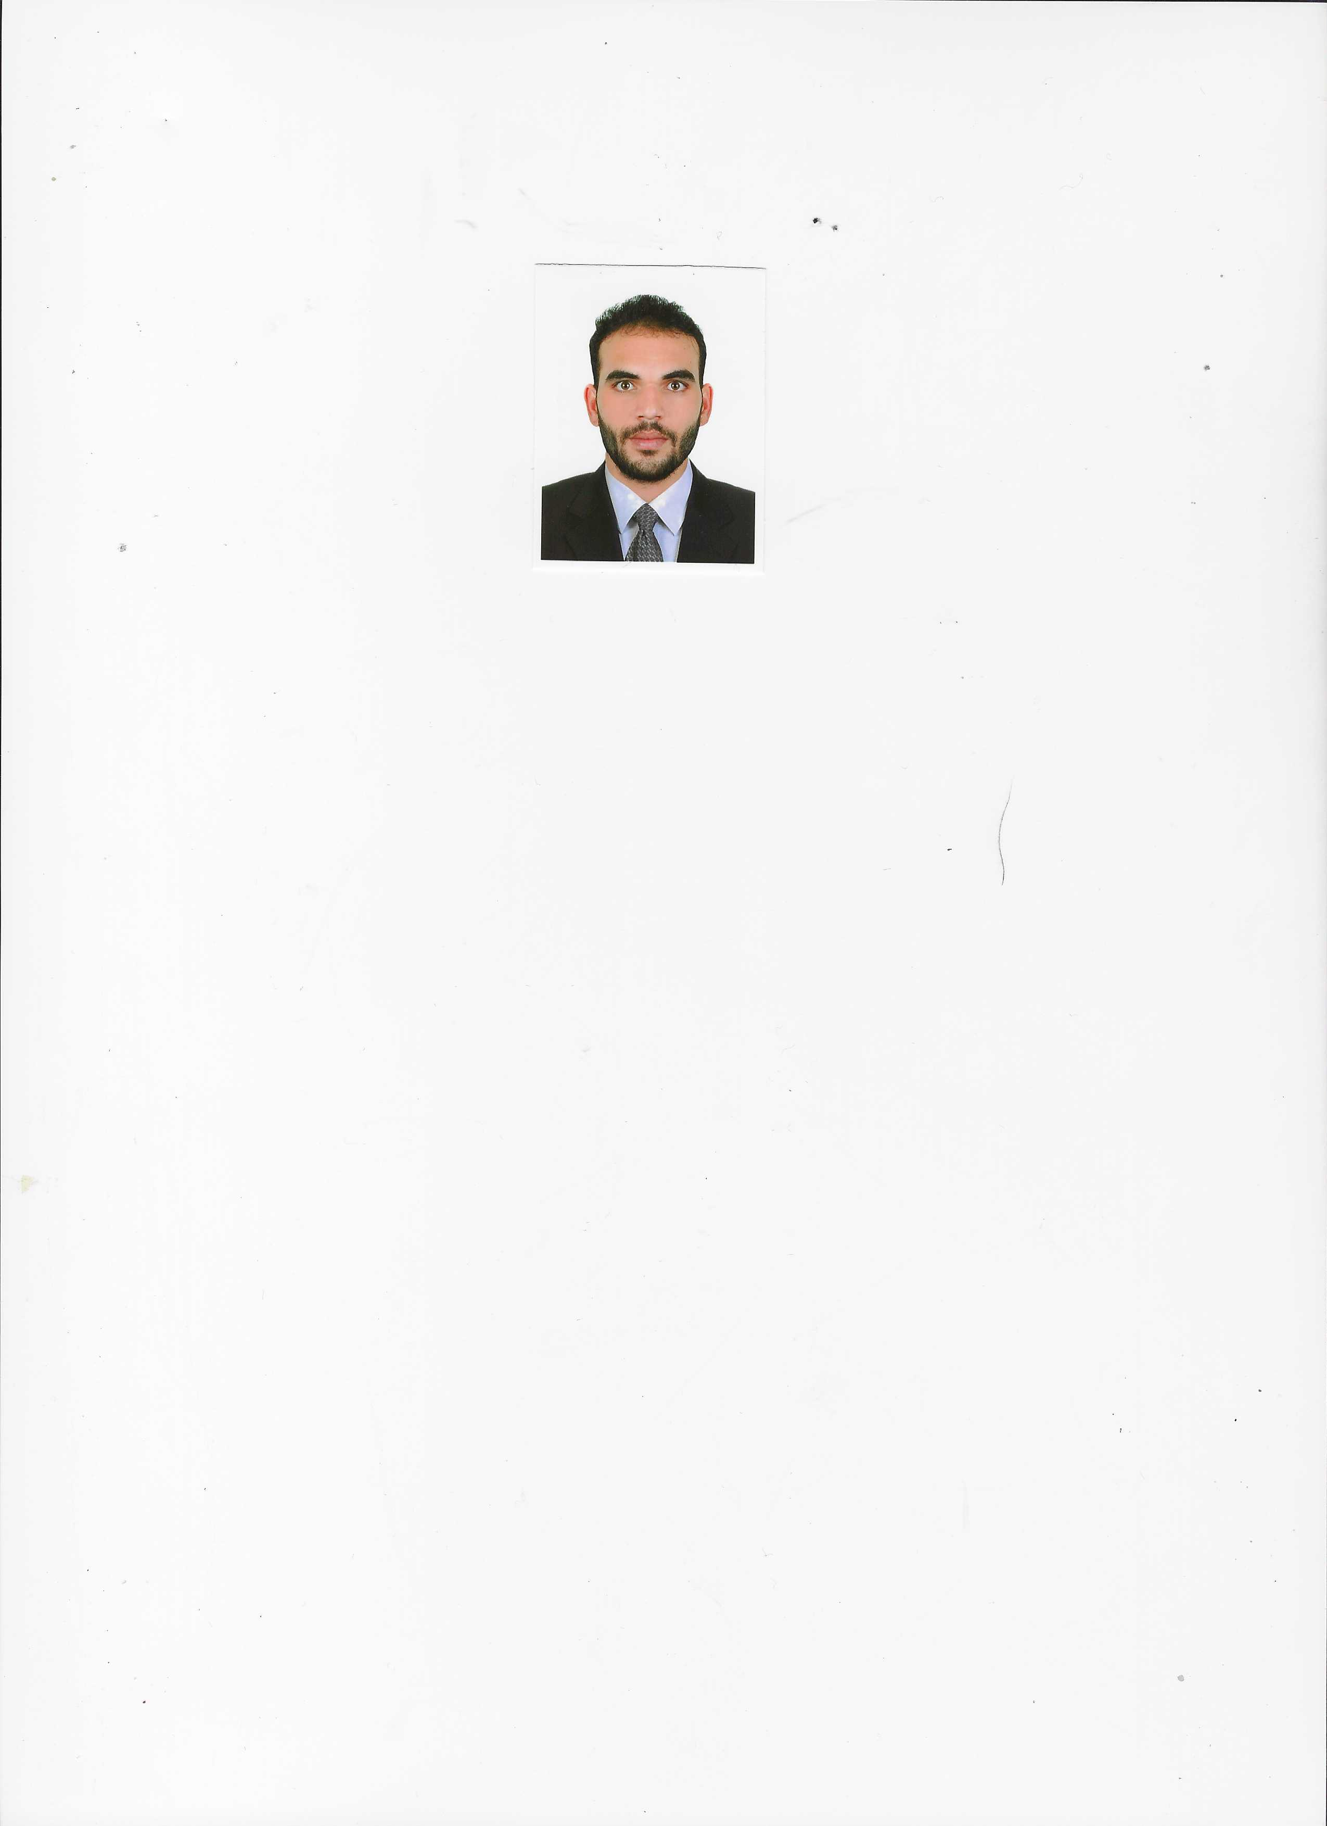 Mohammad Shamim

*Mob****:+971- 0567905711***

*Email Id:shameemkhan22* ***@gmail.com***

*sharjah ,UAE.*

***Objective:***

*To become a part of a dynamic group where I could explore the skills and capability which gained in the whole working career and in present job experience and to serve in a challenging work environment with equally vast opportunities of career development based upon achievements results. , and these skills and talented abilities to promote company as much as I can with mydedication and hard work for achieving a grand success for the company and myself.*

* ***Personal information:***
* *Place of Birth : Fatepur , Raipur*
* *Martial Status : Married*
* *Nationality : Indian*
* *Sex : Male*
* *Religion : Islam*
* ***Passport & Visa Status*** *:*
* *Passport No :* ***R4953557***
* *Date of passport issue : 21/11/2017*
* *Date of Passport Expiry : 20 /11/2027*
* *Visa status : Employment Visa*
* ***Academic Qualification :***
* *High school (10th) passed from Raipur India.*
* ***Work Experiances:***

***7 year Work as a Sales Man in Emirates Markets United Arab***

***Emirates.***

* ***Driving Licence:***

***Achieving Driving Licence of No.3 In United Arab Emirates.***

* ***Communication Skill’s***
* *Hindi*
* *English*
* *Arabic*
* ***Professional Skills :***
* *Good public relation skills & well likes by superiors.*
* *Acquainting to the environment and grasping the things faster*
* *Young energetic and hard working*
* *Perseverance, fast learning ability, good communication and analytical skills.*
* *A team worker & can handle work pressure with ease.*
* *Ability and experience to work in a team of multi lingual& multi-nationality.*
* ***Declaration:***

*I hereby declare that all the above-mentioned information are given by me true and correct to the best of my knowledge and belief.*

***Yours Sincerely,***

*Mohammad Shamim*