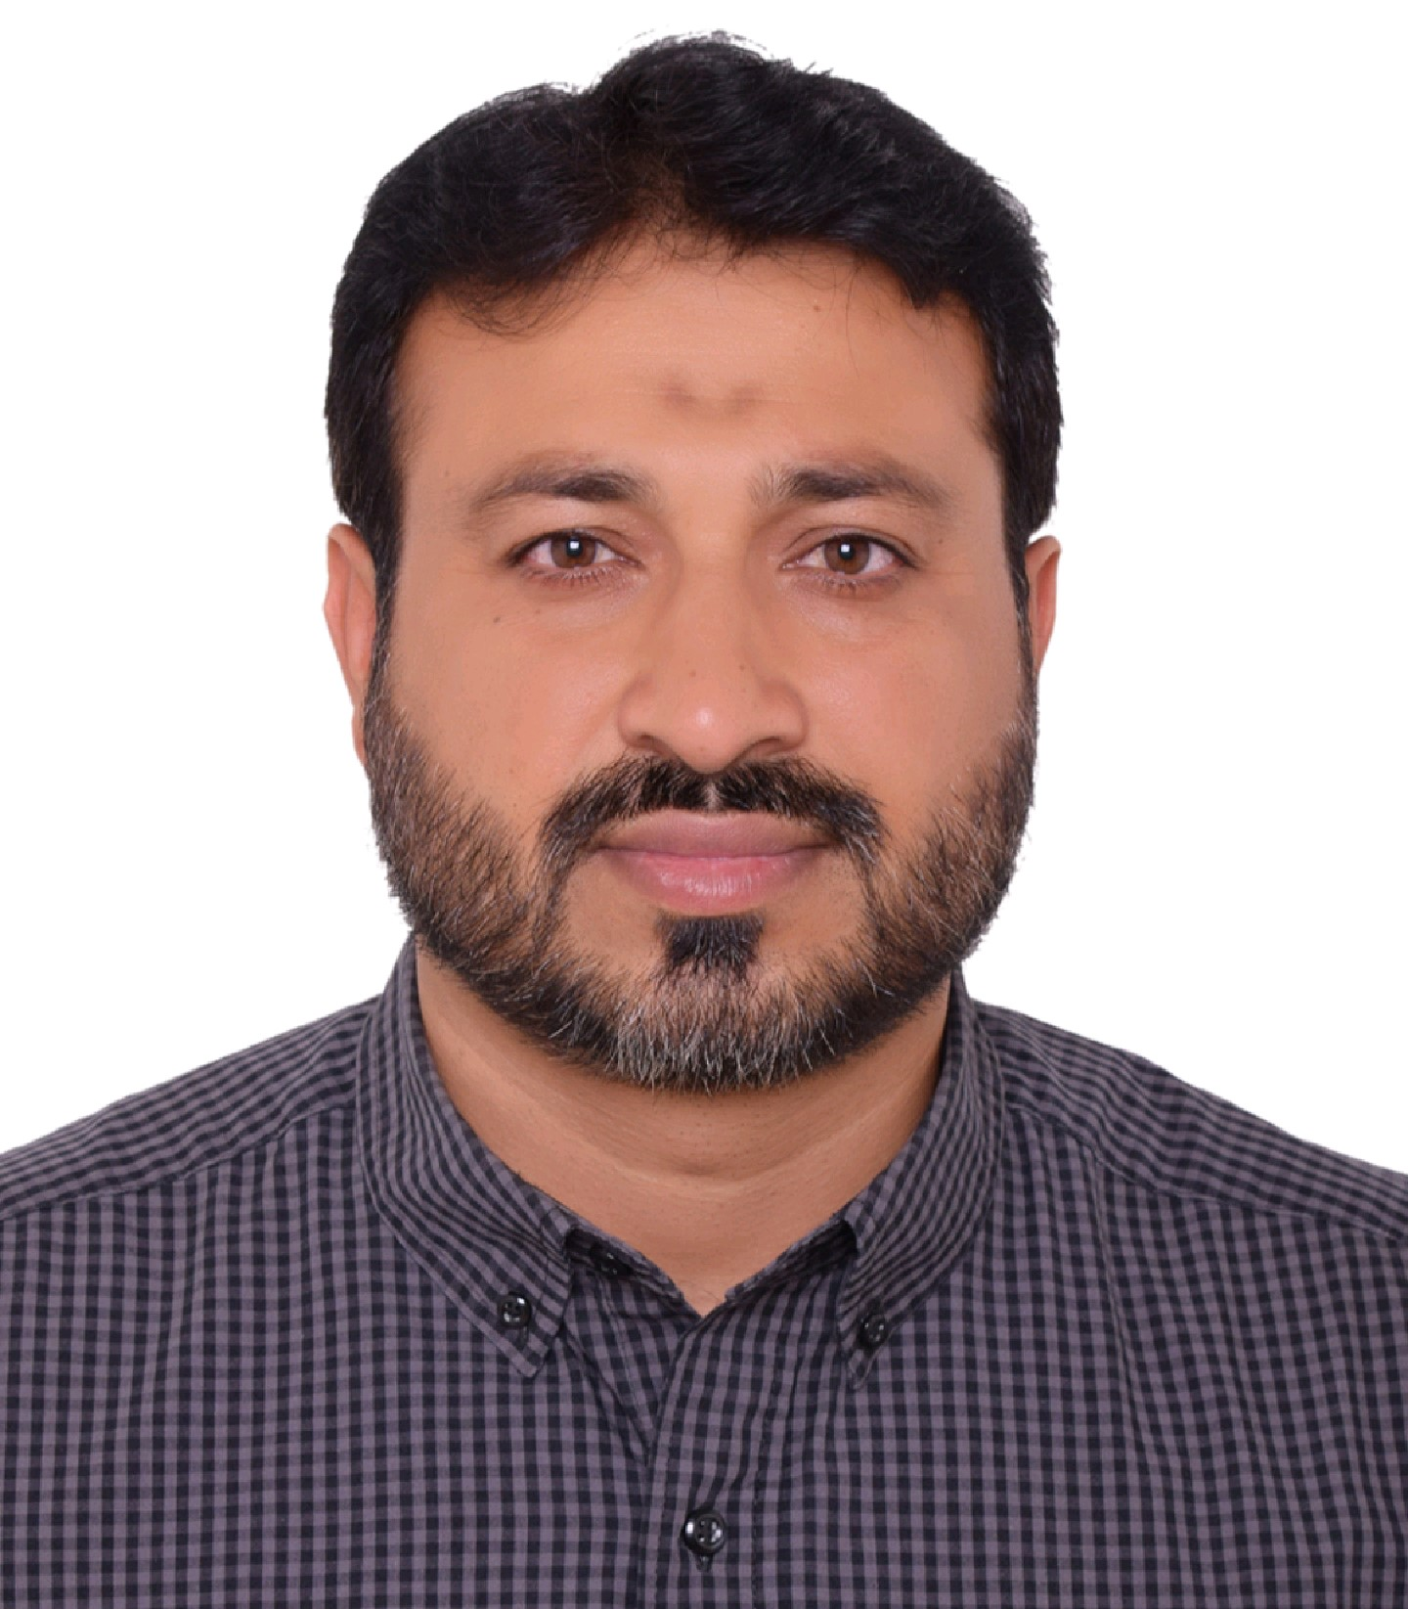
SOHAIL ABBAS

Address: Dubai (UAE)
Cell & WhatsApp #: 050-8143796
E- Mail: sohailminhas2020@gmail.com

Objective

To seek a high responsible position in a reputed organization which not only provides challenges and motivation and training opportunity, long term career growth in the best interests of the industry as well as for me.

Career Summary

Having years of versatile sales & marketing, Administration experience including supervision, management and decision making in the largest FMCG organizations of Pakistan, Saudi Arabia & UAE. I have developed skills and capabilities to perform any type of task and can also work under challenging and pressure situations for achieving targets and handling the sales staff.

Professional Experience:

MEZZAN HOLDING CO. (Unitra International LLC)
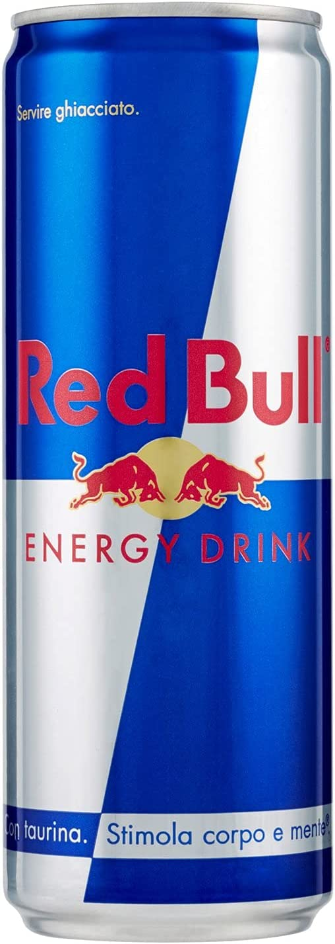
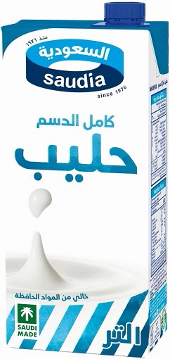
(Red bull, Kitco, Caprisun, Icafe, Nestle)

Area Development Supervisor (ADS) 2021-Present
(TT) Dubai, Sharjah, Ajman & UMQ

- Manage, Guide & Motivate the Van Sales Representatives.
- Setting objectives, overseeing route productivity to ensure sales volume and revenues are achieved.
- Proper execution of all KPI’s (Route Compliance, Productivity, MSL)
- Daily monitoring the distribution of all brands
- Proper focus on range selling
- Plan to cover new outlets in our territory
- Monitoring the recovery (Collection) of team
- Find out new opportunities to improve revenue & visibility
- Proper route riding with the Van and resolve customer complaints
- Monitor Zero Billing of my sales team individually

LYFE GENERAL TRADING 2018-2021
Happy water (Lyfe & Mai Aldhafra Bottled Drinking Water)

Sales Supervisor
(TT, wholesale & Horeca) Dubai & Abu Dhabi

- Manage, Guide & Motivate the Sales team of van Sale Executives with helpers in Dubai & Abu Dhabi
- Conduct daily meetings with team and check sales figures
- Proper follow up the PJP of sales team with physical coverage
- Focus SKU wise Product availability, range selling & penetration
- Generate new potential customers and build strong relationships
- Complete Monthly, quarterly, and annual reviews regarding achievements
- Daily monitoring the SKU penetration of each salesperson
- Ensure proper management of invoicing, discounts, and payments
- Manage purchasing and warehouse related all issues regarding stock
- Plans manpower requirement of the unit
ALAM GROUP OF COMPANIES (www.alamgroup.ae)

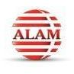
JAWAD AL ALAM TRADING EST
Cash n Carry In-charge (Abu Dhabi) 2016- 2018
(Retail, Wholesale & Horeca)
- Manage Cash n Carry team (25 Persons) & Area along with the sales team of outdoor sales executive & Van salesman’s
- Distributing targets with the help of monthly accumulative figures
- Responsibility for maintaining customer service, credit, and recoveries
- Monitor competitor’s Activities
- Focus Product availabilities, range selling & penetration
- Reaching sales target and increasing profit margin
- Servicing the new customers in our assigned Area
- Proper handling of operational issues


ARAB COMPANY FOR MODERN INDUSTRIES (www.dala.com.sa)

Van Sales Supervisor (KSA) 2010-2016
(Riyadh)-TT & Horeca

- Supervise team of Van Sales representatives with helpers in assigned territory
- Splitting targets of each salesman with accumulative analysis
- Daily target monitoring with secondary sales
- Arrange meetings with salesman according to our achievement figures
- Proper market visit in daily basis to check physical product availability and coverage
- Proper planning in new channel developments
- Work about the market analysis to saw competitors’ activities

UNILEVER PAKISTAN.

Sales Supervisor (Distribution based). 2006-2010

- Manage Territory along with Sales team of DSR’s and Salesman’s
- Proper distributor management
- Proper time management with my sales team
- Daily target monitoring with secondary sales
- Develop and execute action plans to increased market share and profitability
- Back check for the POS material in assigned area
- Increased sales for different type of resources with the help of our seniors
- Launching & Introducing New Product in the Market
- Proper Display & Merchandising of the company’s products
- Ensure Market coverage and productivity of our company
- Stock Management in different locations

Educational Qualification

- Master of Business Administration (MBA-Marketing) 2005-2006 AIOU, Islamabad
- Bachelor of Computer Science (BCS) 2000-2003 AIOU, Islamabad

Languages Fluency

- Excellent Spoken & Written English, Urdu, Punjabi & Arabic.

Computer Skills

- Proficient in use of MS Office (Word, Excel, Power Point, etc)
- Internet (Email, Web, Searching, Browsing, etc)

Personal Information

- Father’s Name: Zafar Abbas
- Date of Birth: 22 October ,1981
- Nationality: Pakistani
- Driving License: Pakistan, KSA & Valid UAE(GCC)

