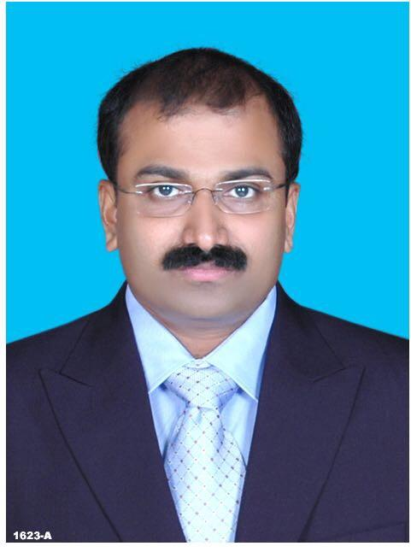

**Personal Details**

Name **: KURUVATH SOMANADHAN**

Gender **: Male** Civil Status **: Married**

Country & Place of Birth : **India, Nandipulam** Date of Birth : **31-May-1969**

Nationality : **India**

Permanent Address:

**Parthivam”**

**Adiyat Lane, Trichur**

**Kerala, India**

Phone No**:**

**+91 918 845 8361**

**+91 799 402 9302**

**+91 487 296 3006**

Other details:

*E-mail for correspondence:* [**somankuruvath@gmail.com**](mailto:somankuruvath@gmail.com)

**trc_soman@yahoo.co.in**

Driving License : UAE, Kuwait, Kenya & India

**Contract Information**

Availability : Immediate

**Areas of Expertise**

**Accounting :** 14 years **Auditing :** 10 years

**Financial Analysis and Reporting :** 24 years

**Language Skills**

Mother Tongue : **Malayalam**

*Working Language :* **English**

**Education**

***Highest Educational Degree* : C A**

*Name of Education Institution* **: Institute of Chartered Accountants of India**

*Year*  **:****1999**

*Title of degree* **: Chartered Accountant**

**Information Technology**

***Course Name* : DISA**

*Name of Education Institution* **: Institute of Chartered Accountants of India**

*Status*  **: Completed the Course and waiting for the**

**results**

**Certifications**

GST Certification issued by the Institute of Chartered Accountants of India

**Pursuing Courses**

Name of the course Organisation

Company Secretary ICSI

**Experience Summary**

**OVERSEAS EXPERIENCE – POST QUALIFICATION**

Particulars Company Experience Years Country

Manufaturing Division MNC 7 Kenya

Retail Division MNC 7 Kuwait

Project Division MNC 2 UAE

**DOMESTIC EXPERIENCE – POST QUALIFICATION**

Particulars Company Experience Years State

Audit Division Sethu, Santhan&Co 1 Kerala / India

Consultancy Private 2 Kerala / India

**DOMESTIC EXPERIENCE – PRE QUALIFICATION**

Particulars Company Experience Years State

Audit Division Sethu, Santhan & Co 3 Kerala / India

Hospital Service Heart Hospital 2 Kerala / India

**TOTAL EXPERIENCE**

Years

Post Qualification 19

Pre -Qualification 05

Total 24

**Employment Details**

*Exact Title of Position held* : **DGM**

*From:*-*To* :**9/2023 –**

*Name/address of employer*  : **ASAP Kerala**

*Brief description of duties and responsibilities* :

**Directing all finance- related strategies, initiatives and activities for organization- wide financial accounting and reporting. Primary responsibility includes accounting, budget planning and control, cash management, treasury, and tax handling functions.**

**Employment Details**

*Exact Title of Position held* : **CFO**

*From:*-*To* :**4/2023 – 06/2023**

*Name/address of employer*  : **Ajfan Dates and Nuts Ltd.**

*Brief description of duties and responsibilities* :

**Directing all finance- related strategies, initiatives and activities for organization- wide financial accounting and reporting. Primary responsibility includes accounting, budget planning and control, cash management, treasury, and tax handling functions.**

**Employment Details**

*Exact Title of Position held* : **CFO**

*From:*-*To* : **6/2021 – 8/2022**

*Name/address of employer*  : **Sethus Exports India Pvt Ltd**

*Brief description of duties and responsibilities* :

**Directing all finance- related strategies, initiatives and activities for organization- wide financial accounting and reporting. Primary responsibility includes accounting, budget planning and control, cash management, treasury, and tax handling functions.**

**Employment Details**

*Exact Title of Position held* : **AGM**

*From:*-*To* : **2/2021 – 5/2021**

*Name/address of employer*  : **K S R T C**

*Brief description of duties and responsibilities* :

**Accounting system review and implementation of necessary changes, System implementation and Internal Audit**

**Employment Details**

*Exact Title of Position held* : **CFO**

*From:*-*To* : **9/2020 – 12/2020**

*Name/address of employer*  : **BRD Group of Companies - INDIA**

*Brief description of duties and responsibilities* :

**Directing all finance- related strategies, initiatives and activities for organization- wide financial accounting and reporting. Primary responsibility includes accounting, budget planning and control, cash management, treasury, and tax handling functions.**

**Employment Details**

*Exact Title of Position held* : **Audit Manager Projects - UAE**

*From:*-*To* : **7/2017 – 02/2019**

*Name/address of employer*  : **Lulu Group International**

*Brief description of duties and responsibilities* :

**To setup Project Audit team and department at the Head office in order to evaluate deficiencies or improving areas in the process, system or proposal which covers both Financial and Technical aspects of the projects.**

*Exact Title of Position held* : **Regional Auditor – Kuwait Operations**

*From:*-*To* : **5/2009 – 6/2017**

*Name/address of employer*  : **Lulu Hypermarket LLC**

*Brief description of duties and responsibilities* :

**To set up Internal auditing team in the region in helping the company to achieve the stated objectives by using a systematic methodology for analyzing business processes, procedures and activities with the goal of highlighting organizational problems and recommending solutions.**

*Exact Title of Position held* : **Regional Finance Controller (East Africa)**

*From:*-*To* : **2/2003 - 4/2009**

*Name/address of employer*  : **EMKE Garments Kenya Ltd.**

*Brief description of duties and responsibilities* :

**Controlling three divisions - manufacturing, import & export and trading and oversee financial analysis, financial audits, G/L, A/R, A/P and fixed-asset accounting. Develop and manage external financial relationships (e.g., banks, insurers, auditors) and constantly look for ways to strengthen overall financial performance.**

*Exact Title of Position held* : **Consultancy Engagements**

*From:*-*To* : **2/2000 - 1/2003**

*Brief description of the Services* :

**Providing Technical and professional services for new entrepreneurs, verification and certification of accounts, providing taxation services both direct and indirect taxes. Carried out Statutory, Revenue Audit and Inspection of Nationalised and scheduled Banks in India.**

*Exact Title of Position held* : **Audit Manager**

*From:*-*To* : **10/ 1996 - 1/2000**

*Name/address of employer*  : **M/s Sethu Santhan & Co. - Kerala, India**

*Brief description of duties and responsibilities* :

**Plan and schedule audit programs, ensure completion of audits on time, review and assess completion of audits, coordinate with clients about auditing practices, train and mentor audit assistants and other audit staff, analyze financial data, records, reports and statements, initiate internal audit controls for effective financial management, maintain and update financial databases including audit findings, coordinate with the management to take necessary action on audit findings, integrate best practices and systems into the audit programs**

*Exact Title of Position held* : **Accounts Manager**

*From:*-*To* : **11/1994 - 9/1996**

*Name/address of employer*  : **Trichur Heart Hospital Ltd, - Kerala, India**

*Brief description of duties and responsibilities* :

**Planning and directing accounting activities, assisting in the development and implementation of goals, policies, priorities and procedures relating to financial management, budget, accounting and / or payroll, supervising and participating in the preparation of various financial statements and reports, directing internal audits involving review of accounting and administrative controls, coordinating in the preparation of external audit materials and external financial reporting and reviewing financial statements with management personnel.**

**Computer Skills**

Word processor, Spreadsheet, Operating Systems, Internet & e-mail

Other software : **SAP**

Accounting Software : **QuickBooks**

**Fellowships.**

**Fellow Member of THE INSTITUTE OF CHARTERED ACCOUNTANTS OF INDIA**

**Verification of Date and Place of Application**

I certify that the statements made by me in my personal profile are true, complete and correct. I also certify that any documents provided in support of my application are authentic and accurate.

Place : **Thrissur**  Date :18/10/2023

Full Name as Signature : **Somanadhan**