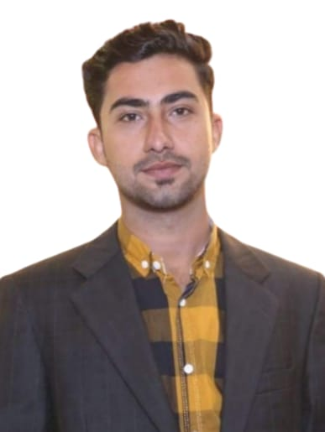 **SHOAIB UDDIN KANDHRO**

**PROFILE:**

I am an enthusiastic, self-motivated, reliable, responsible and hard-working person. I am a mature team worker and adaptable to all challenging situations. I am able to work well both in a team environment as well as using own initiative. I am able to work well under pressure and adhere to strict deadlines.

**PERSONAL INFO**

Nationality : Pakistani

Date of Birth : 14/03/2001

Gender : Male

Marital Status : Single

Visa status : Visit Visa

**EXPERIENCE:**

* **SALESMAN:**

Imtiaz supermarket Karachi – Pakistan (May 2021 – June 2022)

* Showcased product features to customers and discussed technical details to overcome objectives lock in sales.
* Increased sales by offering advice on purchases and promoting additional products.
* Trained and mentored new sales representatives

**CONTACT**

PHONE: +971543867248

EMAIL: [shoaibkandhro@gmail.com](mailto:shoaibkandhro@gmail.com)

Address:

Villa 45 street no 6A Al Bada, Satwa, Dubai, U.A.E

* **CASHIER:**

Imtiaz supermarket Karachi – Pakistan (March 2020 – April 2021)

* Answered questions about store policies and addressed customer concern
* Restocked and organized merchandise in front lanes.
* Operated cash register for cash, check, and credit card transactions with excellent accuracy level.
* **FRONT DESK RECEPTIONIST:**

CITY hospital Larkana, Sindh, Pakistan (July 2022 – May 2023)

**LANGUAGES**

English ◼◼◼◼◼◼◼

Urdu ◼◼◼◼◼◼◼

Sindhi ◼◼◼◼◼◼◼

Hindi ◼◼◼◼◼◼◼

* Greeted visitors upon arrivals, verifying identity and booking details and issuing visitor passes.
* Expertly handled complaints and recorded customer feedback to enhance guest experience.
* Kept reception area clean and neat to give visitors positive impression of the company.

**SKILLS**

* Front office Management
* Microsoft office
* Customer and client relation
* Active listening
* Cash counting accuracy
* Communication skills
* Team work
* High organized
* Patience

**EDUCATION:**

* **Bachelor of Science – Science**

Govt Degree College Nasirabad Affiliated with S.A.L.U Khairpur

(Marks: 1195/1750) (06/2018 – 09/2020)

* **Intermediate:**

Govt Degree College Nasirabad

(Marks: 806/1100) (05/2016 – 05/2018)

* **Matriculations:**

Govt boys high School Nasirabad

(Marks: 635/850) (04/2011 – 04/2016)

**DIPLOMA:**

* **Computer information technology (C.I.T)**

Virtual academy of computer science Nasirabad.