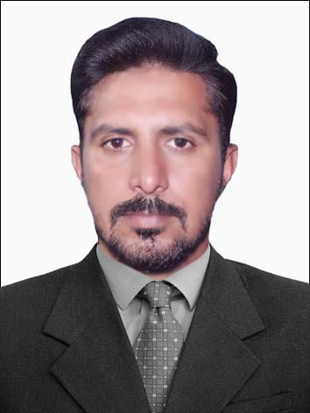 *Sajjad Ahmad*

***Skilled Accounting & Finance Professional***

*sajjadacca33@gmail.com*

www.linkedin.com/in/sajjad-ahmed933

 +92-3154333436 +92-3154333436

*Why* ***Sajjad?***

* Task-focused and resourceful professional with expertise in all facets of financial analysis. Skilled in collaborating with all members of an organization to achieve business and financial objectives. Instrumental in streamlining & improving processes, enhancing productivity.
* Diligent professional with outstanding communication skills and solid commitment to establishing meaningful relationships with clients. Has demonstrated ability to plan and prioritize workflow to meet established deadlines. Proficient in managing and developing financial reports and controls using staffing efficiencies, has a proven record in conducting training sessions.

|  |  |  |
| --- | --- | --- |
| **CORE STRENGTHS & ENABLING SKILLS** | | |
| * Accounts Management * Financial Management * Budgeting & Forecasting | * Accounts Payable & Receivable * Payroll Processing * Cash Flow Management | * IFRS, ISA, IAS & GAAP * Business & Financial Reporting Skills * Team Building & Leadership Skills * Communication & Presentation Skills |

# PROFESSIONAL EXPERIENCE

**Khyber College of Dentistry, Peshawar.**

I am currently working as a Finance Officer at Khyber College of Dentistry, Peshawar (From 1st July 2022- till now)

**Responsibilities:**

* Supervision of Bill Processing, Checking Supplier payment, Tax working, preparing one line Budget annually, Reappropriation of Approval, Service Book Checking, Bank Reconciliation, Ledger to Ledger Reconciliation, Looking of Hospital and Student receipts on regular basis, Incorporate changes in Payroll, Liaison with external and internal auditors, Reporting to DEAN and DF of the institute etc.

**Beaconhouse School System (Pvt.) Limited, Peshawar, Pakistan.** Worked as ***“Accounts Officer”, Dec 2019*** to Jan 2022. **Responsibilities/Accomplishments:**

* Preparing bank reconciliations of ABL and Dubai Islamic bank, processed payroll, and updated staff records on Beams, while preparing Imprest and reporting to the Assistant. manager cluster. Oversaw vendors’ registration, booking/liabilities, and issued a cheque.
* Supported WHT/GST deduction, and the same was paid to FBR while executing electronic filing, handling cash, and maintaining a fixed asset register. Prepared annual budget (CAPAX) on BEAMS, while enrolling staff into EOBI counseling with Govt. department

**Rehman Medical Institute (Pvt.) Limited, Peshawar, Pakistan.** Worked as ***“Finance Officer”***, April 2017 to Nov 2019 **Responsibilities/Accomplishments:**

* Implemented COC (campus on clouds) and upgraded easily retail software for cash management. Reconciled UBL & MCB monthly, while executing financial analysis of MBBS students & booking their fees in Dynamics 365 and reconciling in COC
* Monitored activities of MBBS departments, BDS, DPT, AHS & nursing, and reported to the respective departments. Handled ledger-to-ledger reconciliations, maintained vendor payment records, reconciled all cash creation at end of day against the supervisor's manual record and booked into Easy Retail software, while processing cheques & managing filing relating to the receivable section

# 

# PROFESSIONAL TRAININGS, CERTIFICATIONS & DIPLOMAS

* **Microsoft Office Suite,** Subhash Institute of Computer Science
* **Computer Accounting Training,** Sindh Board of Technical Education
* **Concept of Internal Control and Basic Concept of Management Accounting & Business Modules,** SMEDA

# PROFESSIONAL QUALIFICATIONS

* **Certified Public Accountants, Pakistan** **(2025)** CPA
* **Association of Chartered Certified Accountants, UK (2017**) ACCA
* **University of Peshawar, Peshawar, Pakistan** (2016) M.Sc. – Economics
* **University of Peshawar, Peshawar, Pakistan** (2013) B.A
* **Certified Accounting Technician (CAT), 2008**