**CURRICULAM VITAE**

**SALIM MALIK M**

**MOBILE NO-0557234789**

**SAUDI ARABIA RIYAD**

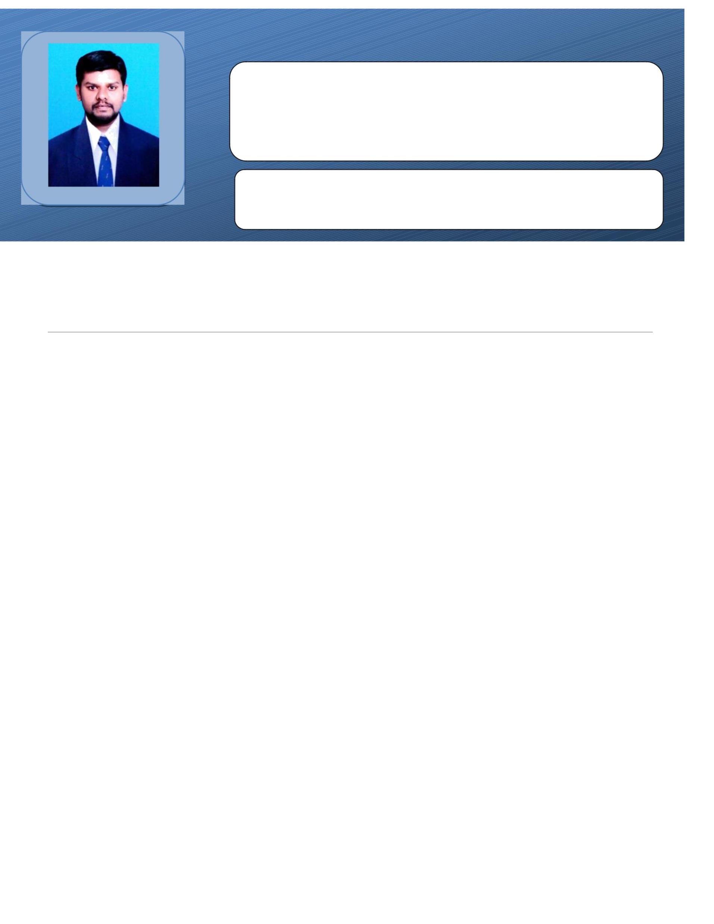 **salimmalik.y89@gmail.com**

**CAREER OBJECTIVE**

To be to work and be a part your prestigious company that would further enhance the knowledge and the discipline built in me and would give me an opportunity to learn and handle new things and tasks.

**WORK EXPERIENCE**

* Worked at **WE ONE ENGINEERING WORKS. Saudi Arabia**, Dammam

As a **Store keeper**- **3 years** (2011 to 2013)

* Worked at **INTERNATIONAL SUPPLY EST**, **Saudi Arabia**, Dammam

As a **Store keeper** -**4 years** (2013 to 2017)

* Worked at in **ELECTRICAL LIGHTING COMPANY.LLC,** Dubai

As a Store keeper from dec’18 to 2022

* Present working now store keeper and salesmen GOLDEN SECURITY TRADING.CO SAUDI ARABIA RIYAD.

**PROFILE SUMMARY**

* **WE ONE ENGINEERING WORKS. Saudi Arabia**, Dammam

As a **Store keeper**- **3 years** (2011 to 2013)

* + - * Assignment of activities to workers (Tradesman ,charge hands, Labors)who have the required skill to accomplish the job within tolerance
      * Coordination with, engineers, safety department etc
      * Organizing required materials, tools & equipment to the workplace.
* **INTERNATIONAL SUPPLY EST**, **Saudi Arabia**, Dammam

As a **Store keeper** -**4 years** (2013 to 2017)

* + - * To examine and monitor work progress, materials and construction site to assure safety and make sure that specification re matching with real work to issue invoices
      * Planning of daily activities according to the instruction of engineer, project engineer and the availability of resources
      * Collecting all the required information & explaining these to subordinates
      * **ELECTRICAL LIGHTING COMPANY.LLC,** Dubai As a store keeper 3years 2019 to2020
  + stock checking
  + Forklift Operating
    - * Arranging the materials according to the orders of customer
      * Loading and unloading of materials
      * Packing and labeling the goods for importing to the international customers

## GOLDEN SECURITY TRADING.CO SAUDI ARABIA present working now joining jun2022

* CCTV camera and cabling materials
* Intercom and door phone materials
* WIFI camera and
* Door lock safety attendance kit materials
* Network accessories

## PERSONAL DATA

Name : Salim Malik.M

Father Name : Mohamed Yaseen .P

Date of Birth : 08-07-1989

Gender : Male

Language Know : English, Tamil, Hindi,& Arabic

Status : Married

Visa Status : Employment

Passport No : U7013063

Nationality : Indian

Address : Saudi arabia

**DECLARATION**

I hereby declare that the above-mentioned information furnished by me is true to the best of my knowledge and belief.

Yours faithfully

**SALIM MALIK. M**