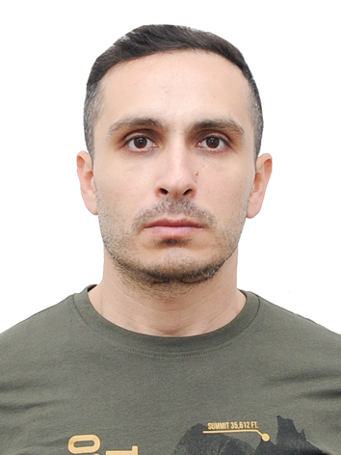

CURRICULUM VITAE

PERSONAL DETAILS:

Name: Sahibjanov Samir Shafigulla
Birth date: 14.11.1982
Birth place: Azerbaijan Republic, Bakı city
Citizenship: Azerbaijanian
Adress: Azerbaijan, Baku, 7 Mkr, House 5|13, app 86
Phone:mobile+WhatsApp +994 5530071 03
E-mail: samirsahibcanov82@gmail.com
Secondary school №126: 1988-1999
Higher education: The Azerbaijan Architectural-building University
Faculty:Mechanization and automation
(1999-2003)
Major: Mechanization and automation –at construction (bachelor degree)

______________________________________________________________________

PROFESSIONAL BACKGROUND
Date:1 june, 2016 –up to present
Organization : Bp “Atilla transport service”
Position: Dispatcher assistant, Driver

Date: 30 june, 2009 – 5 march 2015
Organization : Socar “Azerneftyag”NEZ
Position: The Engineer of Technical Supervision Department
Duties: to verify the thickness of oil and gas pipes with special device, to verify technical indicators of equipments, to verify the thickness of frame of oil and gas reservoirs with special device, to verify suitability of oil and gas reservoirs to exploitation, to verify the daily technical indicators of oil and gas reservoirs which are in exploitation, to draw the weekly report including the technical indicators of equipments which are in expolitation and used in production, to verify the correspondence of equipments to standarts and test the equipments.

Language skills
 | Reading | Writing | Speaking | Listening
Azerbaijan (native) | Excellent | Excellent | Excellent | Excellent
İnglish | Good | Good | Good | Good
Russian | Excellent | Excellent | Excellent | Excellent

Computer skills
Microsoft Office (Word, Excel, Paint, Word-Pad) / Internet Explorer. Office machines: Fax, Xerox, Scanner (Fine Reader)
CERTİFİCATE




