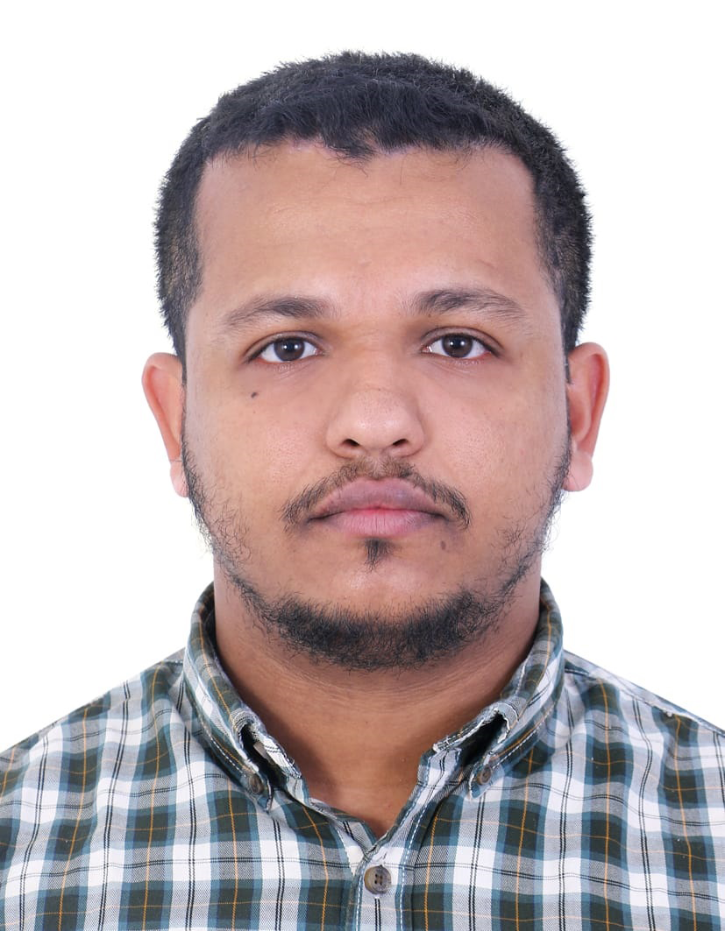**CURRICULUM VITAE**

**MUHAMMED SHABEER P**

**Add** : Dubai, U.A.E.

**Mobile** : +919037353263, +971524193532

**Email** :shabeerpilassery1@gmail.com

**Career Objective**

Looking forward for an organization that offers a challenging, stimulation, learning environment to work in and provide scope for individual & organization development, which offers attractive prospects for long development and career growth.

**Educational Qualifications**

* PLUS TWO | Board of Higher Secondary Education, Kerala
* SSLC | Board of Public Examinations, Kerala

**Work Experience**

2022 - Till Present : Van Sales (Alsafa Poultray)

Dubai, UAE

2018 - 2021 : Butchery Section (Nesto Hypermarket)

Dubai, UAE

2016 - 2017 : Frozen & Chilled and Dairy Section (Nesto Hypermarket)

Dubai, UAE

**DUTIES AND RESPONSIBILITIES:**

* Greet customers.
* Help customers find items in the store.
* Check for stock at other branches or order requested stock for customers.
* Provide customers with information about items.
* Ring up purchases.
* Elevate complaints to management.
* Keep track of inventory.

**Technical** **Skills**

* MS OFFICE
* SAP

**Personal Details**

* Date of Birth : 01/08/1995
* Nationality : INDIAN
* Gender : Male
* Language Known : English , Hindi, Malayalam, Arabic
* Passport Number : N2190417
* Place of Issue : Kozhikode
* Date of Issue : 08/09/2015
* Date of Expiry : 07/09/2025
* **DECLARATION**
* “I hereby declare thal all the information furnished above is true to the best of my belief”