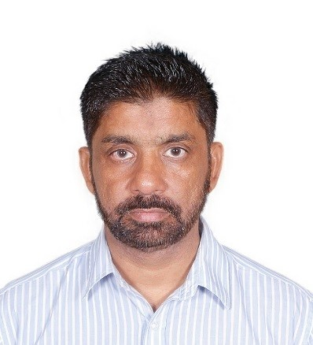

SHAHID MUMTAZ House No.1-G-9-13 NAZIMABAD NO-1 Karachi

ASSISTANT ACCOUNTANT / OFFICE ASSISTANT Contact No: 0331-3017671

E-mail: Shahidmumtaz100@hotmail.com

# Profile

|  |  |
| --- | --- |
| Accounting Skills | Communication Skills |
| Bank Reconciliation. | Rapport building with clients |
| General Transactions. | Communicate with courtesy |
| Parties Ledger Reconciliation. | Exact Pronunciation |
| Branch Accounting. | Good listening Power |

I am currently working as an Assistant Accountant within a public school in Karachi. From my many years of experience I feel I have gained number of key skills which are required in order for me to effectively undertake this jobs role. Previously experiences which make me suitable for the job include, excellent communication skills, both verbal and nonverbal and I liaise well with other professionals. I am a hard working individual, who strives to do well in life. I am very punctual and have a good attendance is I believe that it is key to good performance. I am flexible and enthusiastic. I work well independently, but equally work well with others.

I am aware of relevant I.T technology, as I am a frequent user of modern contemporary technology as part of my education and work experience. I am also able adjust well to the constant development of technology, and am I quick learner. Amongst other skills I am able to priorities my work load, work under pressure and be able to be able to be guided under supervision when necessary.

I am currently searching for the right opportunity to enhance my skills and broaden my experience by filling the position of Assistant being offered by your company.

# Skills

Education Karachi university Bachelors in commerce (B.com) (2011)

Jinnah Govt. Collage Karachi. Intermediate (Pre-Engineering 2008.

Fair Field High School Matriculation (science) (2006)

Diplomas Ms-office (complete course) from ABC center Skills: Word, Excel, Outlook.

6th Month English language course from American center

Skills: Good Communication & fluency in English (Oral & Written)

Experience Mamo Dehli Kabab Restaurant as a Manager 2022 Feb- to be continue

* Mahraja Restaurant as a Manager 2020 April – 2021 Nov

|  |
| --- |
| Foundation Public School PTV Ltd Accounts Assistant 2010 Dec - 2020 |

➢

* 6th month experience working at JFThe Interior Company’s an Assistant accountant (July, 2012-Dec, 2012)
* 1 years’ experience working at BismillahTaqee Hospital a Cashier (Sep, 2011-June, 2012)
* 1 years’ experience working at Fatima traders as a Data Entry Operator. (Oct, 2009-Sep, 2010)

|  |  |
| --- | --- |
| Personal detail | Father’s Name Muhammad Mumtaz  Date of Birth 12thApril, 1979  Gender Male  Nationality Pakistan  Religion Islam  Marital Status Married and 3 son |
| Reference | To show my skills under your dynamic leadership finally will be furnished on demand. |