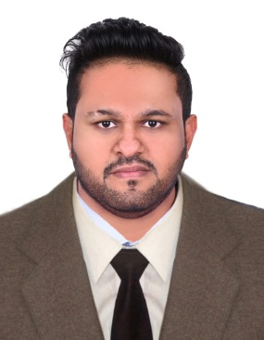

**SHEHIN R.S**

# **Email:** shehinshahul8@gmail.com

# **Contact No**: +971-563161965/ +971-523964262

# **Location:** Dubai, United Arab Emirates

**SUMMARY**

Looking forwar **EXPERIENCES**

d to work in stimulating and challenging environment that could conclude my potential into performance and recognition for hard work, honesty and sincerity thereby contributing to the growth of the organization and myself. Expert in specimen handling, transportation and possess excellent UAE route knowledge.

**SERVICE REPRESENTATIVE**

*DSV SOLUTIONS, PJSC – DUBAI, UAE*

*NATIONAL REFERENCE LABORATORY (NRL)*

*April 2018 - Present*

* Collected blood samples from the hospitals and delivered to NRL Laboratory timely.
* Maintained the temperature for the blood sample.
* Followed all safety protocols and regulations.
* Maintained accurate records of all deliveries and pickups.
* Collected relevant reports and delivered to NRL.
* Communicated effectively with hospital and laboratory staff.
* Performed routine maintenance on the delivery vehicle.
* Excellent knowledge about UAE routes and traffic rules.

**MERCHANDISING & SALES**   *2016 – 2018*

*MUSCAT PHARMACEUTICAL TRADING L.L.C – DUBAI, UAE*

* Determines call schedule by reviewing priorities with supervisor, discussing special instructions, product promotions, new products and price changes
* Completes call report by observing display and pricing of competitors products
* Provides information by reporting growth, expansion or closing of supermarkets in assigned areas
* Maintained quality results by following and enforcing standards
* Handle returns of merchandise and taking new orders
* Suggest ways to improve sales (e.g. Planning marketing activities, changing the stores design)

# 

# **FIELD MARKETING REPRESENTATIVE** *2014 - 2016*

*AL GURG UNILEVER – Dubai, UAE*

Understanding the clients requirements and then customizing the product/services as per their needs

Act as the point persons for outside, inside and partner sales teams

Gather and report customer intelligence to sales teams

Maintained and updated relationship maps for current and prospective clients

Negotiate with retailers and other third-party partners on promotional display and

Merchandise placement.

Produced layout plans for stores.

Forecast profits and sales using computer programs optimize the sales volume and profitability of designated product areas and control stock levels based on forecasts

**EDUCATION**

*CENTRAL BOARD OF SECONDARY EDUCATION | INDIA*

Higher Secondary

*2012*

*CENTRAL BOARD OF SECONDARY EDUCATION | INDIA*

SSLC

*2010*

**LANGUAGES­­­­**

# Malayalam Tamil

# English Hindi

**STRENGH**

* Hardworking, Ambitious and Self-motivated
* Passionate and Dedicated
* Adaptability and Open to learn new things
* Negotiation and Listening skill
* Problem Solving
* Project Management

**PERSONAL DETAILS**

# Nationality: Indian

# UAE Driving License: Light Vehicle

# Passport no: J 6643370

# Visa: Residence Visa

# Marital status: Married

# DOB: 10/04/1992

**SKILLS**

• Well Knowledge in MS Word, Excel, PowerPoint

* Operating system: Windows 98, XP, 7, 8, 10

**DECLARATION**

I hereby declare that the above given information is true to the best of my knowledge and belief.

SHEHIN R.S