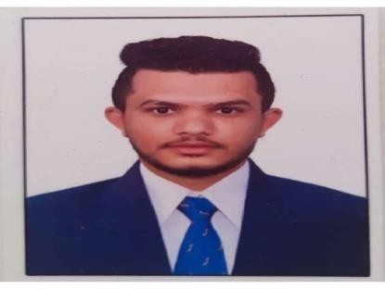
RESUME
Mr.SIVAKUMAR.R
9/16.Telugu Bazaar Street, B.K.Patti Theni – 625531, Tamilnadu, India
Email:kmrthenisiva@gmail.com

MOBILE: +919952327246

OBJECTIVE:

To build career in a growing organization, where I can get the opportunities to prove my abilities by accepting challenges.

SUMMARY:
A Good Team player of giving out the best result with 9 Years of Experience in both Front office Operation & room reservations, providing quality guest service within the guidelines specified by the hotel management.

BASIC ACADEMIC CREDENTIALS
- 2010-2013: B.sc psychology Bharathiyar University - Coimbatore
- 2009-2010 (12th Std) State Board Govt Hr.Sec.School, Allinagaram,Theni
- 2007-2008 (10th Std )State Board Muthaiah High School, Allinagaram Theni

SKILLS:
- MS Office
- Fourth Dimension and IDS
- Typewriting

STRENGTH:
- Team Facilitator, Leadership quality and hard worker.
- Adaptable and self-motivating person with positive attitude .Willingness to walk an extra mile to achieve success.
- Capable of learning new things quickly.

DUTIES & RESPONSIBILITIES:

- Greets, registers, and assigns rooms to guests.
- Check-in and out, posting bill updating of correspondence for billing instruction document for billing.
- Responsible for proper key control and other security measures.
- Answers telephone in absence of telephone operator.
- Works toward a 90% walk-in conversion rate goal.
- Answers inquiries pertaining to hotel services, registration of guests, shopping, dining, entertainment, and travel directions.
- Keep records of room availability and guests’ accounts. Operates the front office computer system. Makes photocopies if needed.
- Computes bill, collects payment, and makes change for guests.
- Makes and confirms reservations.
- Posts charges such as room, food, liquor, or telephone, to guest folio.
- Checks out guests and inquires about their stay.

ADMINISTRATIVE SKILLS:
- Good customer service and problem solving skills.
- Good communication and flexibility to handle and work as a team.
- Attention to detail, analyzed data to check for errors and inaccuracies.
- Demonstrated ability to solve problems.
- Expand the customer base and increase its revenue

EXPERIENCE:
- Worked in Hotel Park Plaza – Coimbatore (From:-03/09/2010 to 18/05/2013) as a (Front Office Assistant).
- Worked in Hotel Prince Gardens – Coimbatore (From May2013to December- 2013) as a (Front Office Assistant)
- Worked in Hotel CAG Pride – Coimbatore As a Senior Front Office Assistant(From 28/12/2013 To 20/11/2014)
- Worked In Hotel Castello Residency – Coimbatore as a Guest Relation Executive (From 22/11/2014 to 18/02/2020)
- Worked as a Accounts Assistant in Export Company in Dubai 1Year.
- Currently Working in Hotel Rathna Residency (Group of Hotels) - Coimbatore As a Senior Front Office Executive (12/10/2022 to Till Now)

PERSONAL INFORMATION:

Father’s Name : P.Rajangam
Date of Birth : 06.03.1993
Gender : Male
Marital Status : Married
Nationality : Indian
Language Known : English, Tamil, Malayalam, Telugu
Passport Number : W9599128

DECLARATION:
I hereby declare that the information furnished above is true to the best of my knowledge.

( Sivakumar R )

