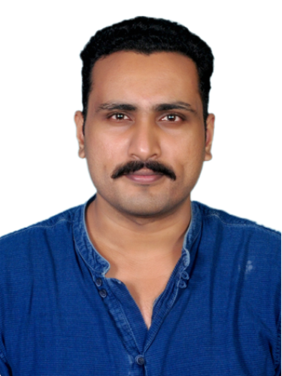 |  | Suhaib Sulaiman  - Security officer  To be a part of an established organization and strive towards corporate and personal success, by delivering my best service and satisfy the superiors with honest & hard work in efficient manner.

Contact
- suhaib.suhaib.s@gmail.com
- +971 508645653
- +91 8547044780

Personal Information

- Father’s Name: Sulaiman M M
- Gender: Male
- Nationality: Indian
- Religion: Muslim
- Date of Birth: 02.04.1993
- Marital Status: Single
- Blood Group: B+ve
- Height: 5'11" (181cms)
- Weight: 90 Kgs

PASSPORT DETAILS
- Passport No: V7181701
- Date Of Issue: 15.02.2022
- Date Of Expiry: 14.02.2032
- Place Of Issue: Cochin

Current Address
We One Head Office,
P.O.Box 18668, Block A,
National Industries Park,
Dubai - U.A.E

Permanent Address
M.A.M Manzil,
Pudunagaram (P0),
Palakkad, Kerala
Pincode: 678503

Languages Known

- English
- Malayalam
- Hindi

Personal interest

- Travelling
- Music
- Social Networking
- Fitness & Excercise

Experience

- From November 26th 2024 to present working in WE ONE as Security Guard.

- From August 2018 to October 2024 worked in Five Star Halwa as Assistant Manager (Customer Service & Distribution).

- From September 2017 to August 2018 worked in Interglobe Aviation (Indigo) as Security Officer.

- From July 2016 to September 2017 worked in Spicejet Ltd as Customer Security Executive.

- Completed Three months Internship at GMR Hyderabad International Airport Limited (Terminal Operation).

EDUCATION

- 2013-2016
BA Literature English
Calicut University

- 2011-2012
Diploma In Airport Management & Customer Care
Aptech Aviation Academy, Coimbatore

- 2009-2011
HSC
GBHSS, Nemmara, Palakkad

- 2009
SSLC
Muslim High School, Palakkad

Acheivements

- AVSEC
- DGR Category-12
- Best Performance at Ramp – Indio Certificate of Appreciation
- Extra Mile Award – Indigo (ASC/HOLD)

Strength

- Hardworking
- Quick Learner and Efficient Time Management Skills.
- Ability to adapt with new situations and willingness to learn and manage things.
- Leadership Quality
- Good Communication Skill

Declaration

I certify that the information given by me is true and correct to the best of my knowledge and belief. I understand that any misstatement described here may lead to disqualification or dismissal of any if engaged.

Suhaib Sulaiman

