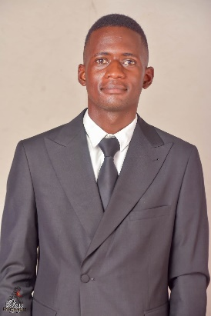  TADIWANASHE MASHUMBA  Contact: +971 583043804  Email: tadiwamashumba312@gmail.com  OBJECTIVE  Enthusiastic and dedicated customer service professional with over 3 years of experience in fast-paced environments. Passionate about providing exceptional service, ensuring customer comfort, and maintaining safety. Eager to transition further into the Customer service industry bringing strong communication, problem-solving skills, and a positive, team-oriented attitude.  KEY SKILLS  - Exceptional communication and interpersonal skills  - Strong customer service background  - Ability to work effectively in high-pressure situations  - Multitasking and time management  - Team collaboration and conflict resolution  - Adaptability and fast learner  - Proficient in English and Shona  - Positive attitude with a passion for creating memorable experiences  - Focused on safety, compliance, and attention to detail  - Proficient in MS Office Suite and CRM systems  ADDITIONAL INFORMATION  - Willing and able to work flexible hours, including nights, weekends, and holidays  - Passion for travel and the aviation industry  - Knowledge of safety and emergency procedures | PROFESSIONAL EXPERIENCE  Customer Service Representative  Bedra Enterprises, Harare | February/2024 – Present]  - Delivered high-quality service to customers, answering inquiries and resolving concerns efficiently  - Ensured customer satisfaction through clear communication, problem resolution, and assistance with product or service-related issues  - Maintained professionalism and a calm demeanour when managing challenging or difficult customer situations  - Worked in a fast-paced environment, handling multiple customer requests while ensuring a high level of service  - Collaborated with team members to achieve department goals, contributing to a positive and cooperative workplace culture  - Assisted in training new staff members to ensure excellent customer service standards were maintained  Retail Associate  Faffles Fashions, Harare | Oct/2023 – Feb/2024  - Provided excellent customer service by assisting clients in selecting products and processing transactions  - Managed inventory and ensured the store environment was clean, organized, and welcoming for customers  - Demonstrated a strong work ethic and commitment to achieving daily sales targets  - Addressed customer inquiries with care and professionalism, often managing multiple tasks simultaneously  - Assisted in visual merchandising, promoting customer engagement and boosting sales  - Handled cash and card transactions accurately and followed all security procedures  Hospitality Associate  Highlands House, Harare | July/2023 – Sep/2024  - Provided high-end customer service in a fast-paced hospitality environment, ensuring guest comfort and satisfaction during their stay or dining experience.  - Managed guest check-ins and check-outs, handled reservations, and coordinated special requests, delivering personalized services to meet individual needs.  - Assisted in organizing events and activities, working closely with team members to ensure smooth operations and guest satisfaction.  - Resolved guest complaints promptly and professionally, always aiming for positive resolutions and maintaining a positive brand image.  - Managed cash registers, processed payments, and ensured adherence to safety and security procedures when handling transactions.  - Promoted hotel services and amenities, increasing guest engagement and repeat business through excellent customer interactions.  EDUCATION  High School Diploma  Seke 1 high School, Chitungwiza | Graduation Year 2022  Software Development Diploma  ZOMAC Digital, Harare | Graduation Year 2024  References available upon request.

