**RESUME**

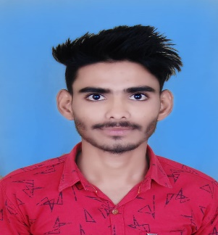

**TAFSEER AHAMAD**

Location: UTTAR PRADESH INDIA

India Contact No. : +917525922398 & +916392239431 ( WhatsApp)

Email: [khantafseerkhan786@gmail.com](mailto:khantafseerkhan786@gmail.com)

**CAREER OBJECTIVE:**

Seeking to work in an organization that offers me to learn, grow, and enhance my skills and where I can utilize my technical skills to fulfill the needs of the organization.

**ACADEMIC QUALIFICATION:**

* **B.Com** from **Siddharth University, Kapilvastu, Siddharth Nagar (U.P)**
* Intermediate from Board of High School & Intermediate, Education UP
* High School from Board of High School & Intermediate, Education UP

**SOFTWARE SKILL:**

* **ADCA ( ADVANCE DIPLOMA IN COMPUTER APPLICATION )**

**SKILL:**

* CASH HANDLING
* CUSTOMER SATISFACTION
* COMMUNICATION SKILL
* SALES OPERATIONS
* CASH MANAGEMENT
* BILLING
* INVOICING

**Professional experience :**

* **CASH HANDLING EXPERIENCE ONE YEAR**
* Worked as sales and marketing executive for National Enterprises (PVC door manufacturing and supply) from January 2022 to January 2023

**PERSONAL STRENGTH:**

* Honest
* Willingness to learn new skills.
* Hard working.
* Leadership quality.
* Can create a good atmosphere and relations among management, seniors, and juniors.
* Can perform efficiently in the team as well as individually.

**PERSONAL DETAILS:**

|  |  |
| --- | --- |
| **Father’s Name** | Mr. Jalal Ahamad |
| **Date of Birth** | 05/07/2000 |
| **Gender** | Male |
| **Nationality** | Indian |
| **Marital Status** | Single |
| **Language Known** | Hindi, English &Urdu |
| **Hobbies** | Reading books, cooking, playing Cricket, Playing volleyball. |
| **Permanent address** | Vill – Bairwa Bankatwa, Post – Khoria  Bazar, Police Station – Nautanwa  District–Maharajganj , Uttar Pradesh – 273164 |

**DECLARATION:**

I hereby declare that the information in this document is correct up to my knowledge and I bear the responsibility for the correctness of the above-mentioned particulars.

**Place: INDIA ( TAFSEER AHAMAD** )

**(+917525922398 )**