  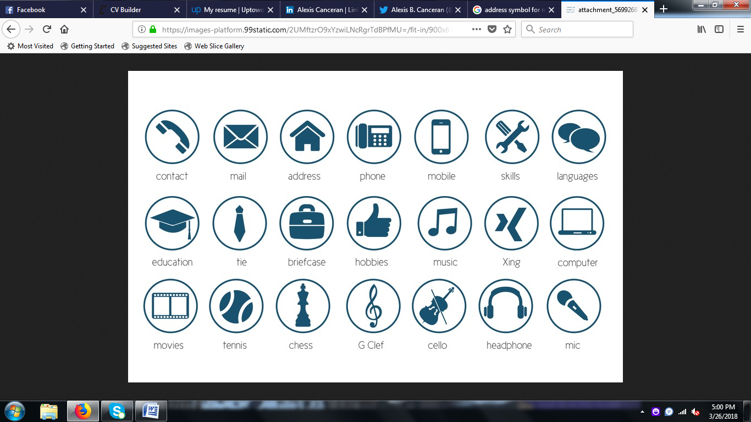  tonnylule4@gmail.com  +971527511322  Al yaseemen building,  Al jurf Ajman United Arab Emirates  Date of birth; 12/09/1991  Marital status; married.  Visa status; own.  /Freelancer /Free zone Visa (01/01/2023 - 01/29/2025)  Nationality; Ugandan  Language. English | TONNY LULE  OBJECTIVE  To obtain a job, which offers diverse responsibility in customer service and sales department, where I can apply my selling passion, customer service abilities and positive attitude to bring more sales and customer satisfaction and to become valuable to my employee as well as improving my career in fast and growing company.  EDUCATION  MAKERERE BUSINESS INSTITUTE KAMPALA UGANDA  -bachelor’s degree in information technology  ST PETERS SENIOR SECONDARY SCHOOL KAMPALA UGANDA – CERTIFICATE OF ADVANCED HIGHER EDUCATION  KEY SKILLS  - Microsoft Office  - Retail Cashier  - Promotes honesty and Integrity.  - Customer Service  - Telephone Etiquette  - Good Time management Skills  - Able to work under pressure.  - Attention to Detail  - Ambitious  - Known to generate and retain customers to achieve.  the company’s sales targets  - Ready to learn and share my knowledge with the team.  WORK EXPERIENCE  INTELLECTUAL CAPITAL ARABIA (BALQUEES HONEY) (2021 – 2022), UAE  CUSTOMER SERVICE / SALES ASSOCIATE  Duties and Responsibilities:  - Solving customers inquires and listening to their objectives.  - Motivating the team to work together and support each other even in stressful times.  - Communicating and evaluating performance standards by focusing on specific behaviors and outcomes.  - Serves customers by helping them select products.  - Processes payments by totaling purchases, cash, or credit.  and debit card  - Provide information about Guarantees, manufacturing.  specifications, care, and maintenance of products  - Assists with inventory, including receiving and stocking merchandise.  HOME CENTER (LANDMARK GROUP) UAE DUBAI (2018 – 2021)  CUSTOMER SERVICE/ SALES ASSOCIATE  Duties and Responsibilities:  - Clearly defining and target prospective customer.  - Describe how your furniture will improve the customer’s life.  - Use plain English, short simple sentences, and a conversational tone.  - Answer the questions in the customer’s mind.  - State the features and benefits of the product.  - Provide a balanced mix of facts and emotional content.  - Complement and elaborate on the product photos.  - Achieving my personal targets set for the day monthly and yearly.  - Welcoming clients on the shop floor  - Billing and parking for the clients after purchasing.  - Merchandising of the shop floor to see that all the products are well demonstrated.  - Receiving and ordering for stock in the system  - Make suggestions and encourage purchase of products.  - Take Stock Inventory  - Selling products and collecting payments (cashiering)  KATUMWA SPORTS CENTER KAMPALA UGANDA. (2016 – 2017)  SALESPERSON  Duties and Responsibilities:  - Arranging products to their receptive brands.  - Welcoming clients to the shop and helping them where necessary.  - Advising clients about the new products and promotions.  - Cashing out customers ‘purchased products or goods.  - Pricing New and promotional products.  - Carrying out weekly and monthly inventory.  - Ordering stock from the warehouse.  SHERATON HOTEL KAMPALA. (2014 – 2015)  WAITER/BARTENDER  Duties and Responsibilities:  - Handle cash, credit card transactions with customers  - Planning drink menus and informing customers about new beverages and specials.  - Selecting and mixing ingredients, garnishing glasses, and serving beverages to customers.  - Checking identification to ensure customers are the legal age to purchase alcohol.  - Taking inventory and ordering supplies to ensure bar and tables are well-stocked.  - Adhering to all food safety and quality regulations.  - Great and escort customers to their tables.  - Present menu and provide detailed information when asked.  - Serve food and drink orders.  - Arrange table settings and maintain a tidy dining area.  - Carry dirty plates, glasses, and silverware to kitchen for cleaning.  TRAINING ATTENDED  SALES TRAINNING) WITH SHARAF DG RETAIL 2019  CUSTOMER SERVICE TRAINNING (MAKERERE BUSINESS INSTITUTE 2010  HOSPITALIRTY TRAINING AT KAMAPALA SHERATON HOTEL. 2014  REFERENCES  Upon Request…

