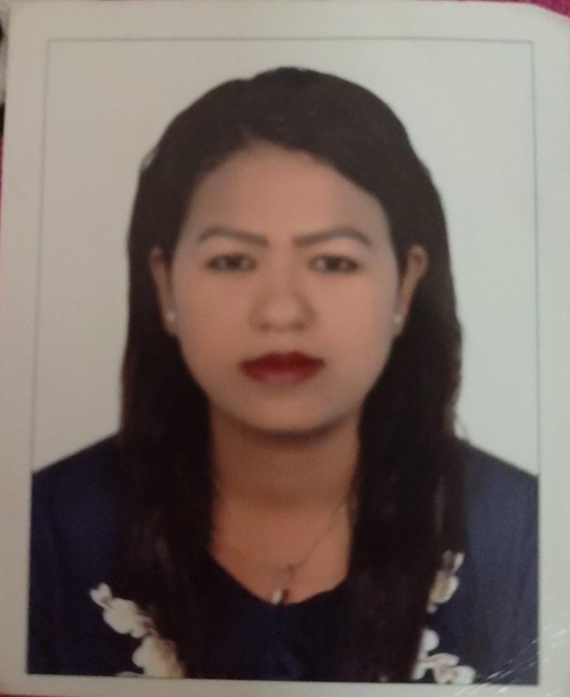

**TARA KHAWAS**

**Cell phone no.: +971544671262**

**Email address: trkhws@gmail.com**

**Post Applied: Cashier**

**Job Objective:**

To work in a result-oriented company in which I can apply my skills and experience in order to contribute to the continuous growth and strength of the property.

**Work Experience**

**Supermarket Cashier**

**Al Madina Hyper Market Shabiya, Abu Dhabi**

**From November 2022 till date**

**Supermarket Cashier**

**International Hyper Market Abu Dhabi**

**From 15th January 2022 to November 2022**

**Job Description:**

* Greeting Customers
* Answering to inquiries
* Replenishing stocks
* Keeping the store clean and organized
* Scanning items
* Bagging groceries
* Collecting payments
* Time management.
* Product knowledge.
* Telephone etiquette.
* Customer service

.

**Housekeeper cum Team Leader**

**Mohammed bin Zayed Office Abu Dhabi, UAE**

**Under Abu Dhabi National Hotels (ADNH)**

**From June 2018 to January 2022**

**Job Description:**

***Administrative and Operational:***

* Manage cleaning department functions including short- and long-term planning, as well as day to day operations
* Conduct performance evaluations in accordance with property and company guidelines and maintain employee files.
* Properly utilize performance feedback, recognition, training, and adherence to company policies, legal requirements
* Maintain the integrity of a property wide inspection program on a regular basis
* Maintain effective communications with other operational departments to effectively resolve situations impacting guest service or malfunctions of departmental equipment
* Provide a positive, empowering, and productive work environment through setting an example and consistency of daily work habits and standards
* Checks equipment’s and pantries and ensure cleanliness and correct storage of all cleaning supplies
* Ensures to give proper hand over to the supervisor

**Machinery knowledge**

* Vacuum
* Scrubbing machine Single disk
* Buffing machine
* High Pressure machine
* Wet and dry
* Bag pack vacuum
* Ride on Scrubber Machine

**SKILLS:**

* **Completed Microsoft Office course form Galaxy Computers Education and Training Institute, Abu Dhabi, UAE**

**STRENGTH:**

* Knowledge of Microsoft/Excel
* Integrity and trustworthiness and dedicated
* Customer /guest focus, motivational skills
* Interpersonal and intercultural skills
* Planning and organizational skills and Training Skills
* Communication and listening skill
* Knowledge of Housekeeping Task and Procedures

**VACCINE STATUS:**

**Fully Vaccinated completed 3 doses of Sinopharm Vaccine**

**PERSONAL DETAILS:**

Nationality: Nepali

Birthday: June 29, 1993

Religion: Hindu

Status: Married

Languages: English, Hindi, Nepali

Passport details: 10740378 Date of issue: 24 January 2018 Date of Expiry: 23 January 2028

**Declaration:**

I hereby declare that all the above information is correct and true to the best of my knowledge and integrity Certificates are available upon your request

Tara Khawas