TERESIA NYAMBURA KAMAU | 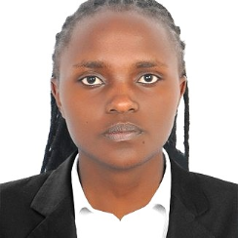
  Address Dubai , UAE 9966
  Phone +971554506734
  E-mail terrykamau49@gmail.com

 | Work History

2023-08 - 2024-05 | Receptionist/Hostess  Cozy Stead -Luxury Restaurant  - Generate financial statements documenting revenue, expenses and liabilities.  - Greeted incoming visitors and customers professionally and provided friendly, knowledgeable assistance.  - Responded to inquiries from callers seeking information.  - Confirmed appointments, communicated with clients, and updated client records.  - Answered phone promptly and directed incoming calls to correct offices.

2022-07 - 2023-07 | Receptionist  National Social Security Fund, Kenya  - Assisted in sale of the properties owned by the Fund through issuing of brochu  - Collaborated with team members to achieve target results  - Engaged with customers to better understand needs and deliver excellent service  - Maximised customer engagement and satisfaction by delivering excellent customer service  - Demonstrated consistent hard work and dedication to achieve results and improve operations.  - Assisted in managing client accounts, resulting in improved customer satisfaction and retention rate  - Helped reduce fraud risk through careful verification of vendor information before processing payments.

 | Education

2020-05 | Bachelor of Science: Economics  Maasai Mara University - Kenya

2018-05 | Certificate in CPA section 2 part 3and 4: Accounts: Accounts  Star College - Kenya

 | Software
Microsoft word
Microsoft Excel
Cloudbeds

