. CURRICULUM VITAE

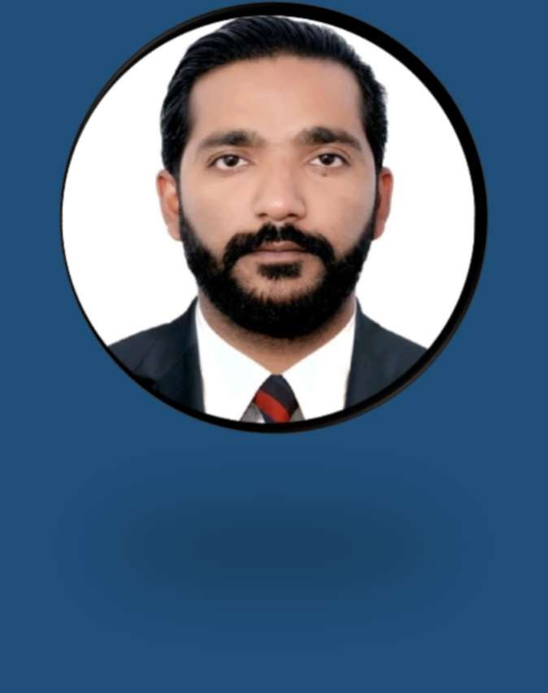

**Mobile No**

**+971- 556474599**

**Email:**

[**taimoorahmed7556@gmail.com**](mailto:taimoorahmed7556@gmail.com)

**TAIMOOR AHMED**

# CAREER OBJECTIVE

To seek excellence in profession in achieving the goals associated with and organization rendering an excellence services according to my academic qualification and work experience.

## Personal Information

Date of Birth : 20-08-1992

Gender : Male

Marital Status : Married

Nationality : Pakistan

## Passport Information

Passport No : FV1168903

Isssue Date : 09-01-2023

Expiry Date : 08-01-2028

Visa Status : Employment

## Educational Qualification

* B.Com

## Languages

* + English
  + Hindi
  + Arabic

**SKILLS**

* + Very energetic result oriented and organized
  + Excellent attention to detail
  + Able to interact and communicate with the supervisors and team members
  + Effective verbal and written communication skills

# WORK EXPERIENCE

* Worked as **AC Technicican** with **NPC LLC** in

**Abu Dhabi UAE** for the period of **03 years.**

* Worked as **Storekeeper** with **Al Ghazal**

**Transport Services LLC** in **Abu Dhabi UAE** for the period

**of 03 years**.

* Worked as a **Security Officer** with **Zims Security Services**

in **Pakistan** for the period of **05 years.**

* Presently working as **Security Officer** with **Royal Shadow Services at AL MAKHTOUM INTERNATIONAL**

**AIRPORT SINCE JUNE 2023**

# RESPONSIBILITIES

* + Sort, organize and store inventory in the proper location
  + Package items and label correctly
  + Report damaged or missing inventory to supervisors
  + Stack and organize large bulk items
  + Update logs and documentation for inventory processing
  + Picking put away receiving qc
  + Ensure workspace is free of debris and remove safety hazards from aisles
  + Work as an active team member to complete team goals
  + Keeping records of incoming and outgoing shipments.
  + Issuing spare parts against job cads recived.
  + Taking Out inventery quarterly basis.
  + Receiving and checking parts as per invoice

**DECLARATION**

I hereby declare that the above-mentioned information is correct to best of my knowledge and belief.

**TAIMOOR AHMED**