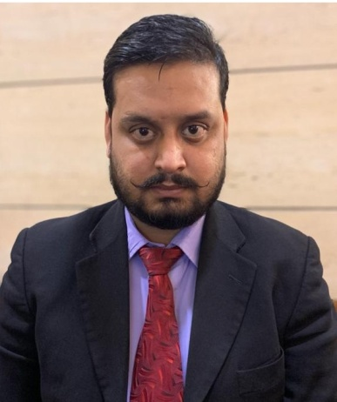**CURRICULUM VITAE**

* **903, Sevanam Crown Dubai Silicon Oasis**

**Contact no:- +971522403692**

**Passport No. :-** **U6191173**

* + - * **Email-Vishalsingh_rajpoot@hotmail.com**

**VISHAL SINGH**

**________________________________________________________________________**

* **Career Objective**

To pursue a challenging and professionally satisfying career and to sustain growth and to provide leadership for high level of process-based teamwork and commitment at all levels. To be creative and innovative and contribute to the resources. To be involved in the job, as much as to enjoy it.

,

**________________________________________________________________**

* **Working Experience& Job Skills :**
* Presently working with Fel’s Café as Café Manager at Dubai Silicon Oasis From 2nd Feb 2023 to till Now.
* Worked with **REVEL HAUS RESTRO PUB**  at Al Mina Road **Hyatt Place Dubai**. From 5th June 2022 to till 31st Jan. 2023
* Worked with **IMLY RESTAURANT** as a Restaurant Manager at **JAIL ROAD** Road, from 29th July 2018 to March 2020.
  + **Role & Responsibility: -**
* Dealing with big companies, Introducing Offering Our Offers.
* Booking the party, according to the customer satisfaction.
* Preparing daily and Monthly sales report.
* Supervision of entire service team
* Conducting training session for the new joining staff.
* Worked with **LOCALE** as an Assistant Restaurant Manager from 21stJuly 2017 to till 28thjuly 2018 at Saket New Delhi.
  + **Role & Responsibility: -**
* Dealing with big companies, Introducing Offering Our Offers.
* Booking the party, according to the customer satisfaction.
* Preparing daily and Monthly sales report.
* Supervision of entire service team
* Conducting training session for the new joining staff.

.

* Worked with **CHARCOAL TANDOOR Grill**s as Captain since Feb.2015 to till (1 year 7 months) sept.2016
  + **Role & Responsibility: -**
* Conducting regular briefing about new updated products,
* Conducting training session for the new joining staff.
* Taking guest order from pos, maintaining.
* Making duty roster, Managing stores and month end inventories.
* Handling guest’s queries and complaint.
* Handle the VIP guest
* Worked with **Pan India pvt. Ltd.** In Food Court as a Shift Supervisor since jan.2010 to Dec. 2012( 2 year 11 months) at select Citywalk
  + **Role & Responsibility: -**
* Deal With the Guest
* Order taking , Guest Handling
* Inventory of Stock’s and File maintenance
* Worked as a Crew Member in **MC DONALD’S** since sept.2008 to Oct.2009 (1 year) at Lajpat Nagar New Delhi.
  + **Role & Responsibility: -**
* Making Burger and Serve the Customer’s
* Order Taking, Suggestive Selling
* **Educational Qualifications:**
* B.sc from Magadh University Patna
* H.S.C. from College of commerce Patna.
* S.S.C. from Patliputra High School Patna.
* **Technical Skills:**
* **Digital Marketing**, SEO, Website Building , Social Network Marketing, Google Ads. Etc.
* M.S Word, Excel , Win2003,2007 and Installation & Troubleshooting
* **Hobbies:**
* Singing Song ,Net Surfing
* **Strengths:**
* A team man and an efficient team worker.
* **Personal Details:**
* Father’s name : Mr. Ramanuj Singh
* Date of birth : 1st Jan, 1986
* Gender : Male
* Marital status : Married
* Languages known : English & Hindi
* Passport No. : U6191173
* **Declaration:**
* I hereby declare that the information submitted is true to the best of my knowledge and belief.
* PLACE:…
* DATE:.....

Sign..

**VISHAL**