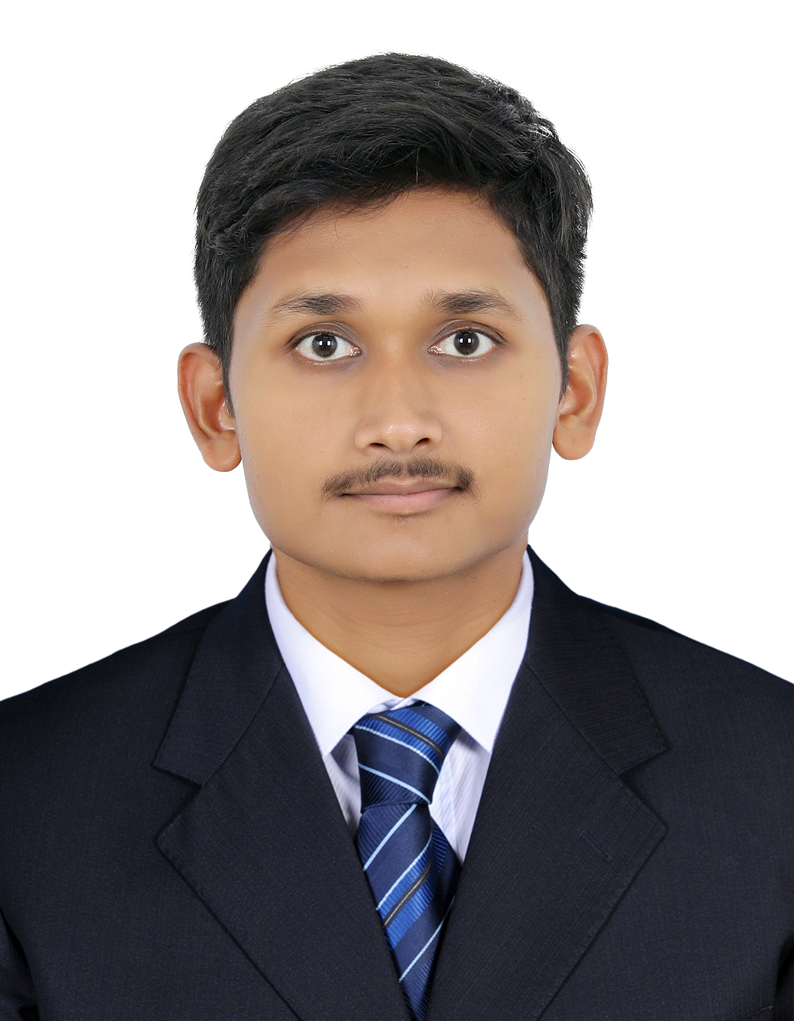

Kombathula vishwa teja

Al nadah, sharjah, UAE▪
Contact +971– 504591813
Emai :-vishwateja1771@gmail.com
Skype : - live:.cid.c72ba99f94ddb5ee

PERSONAL INFORMATION
Country of Origin: hyderabad,Telangana, India
Date of Birth: Jully 17, 2001
Gender: Male

OBJECTIVE To hold a responsible position in a esteemed organization that would make
Optimum use and skills and help me grow professionally in my career and achieve organizational goals.

SUMMARY
- 4 months internship
- IIHM graduate with BHMCT in Hotel Management & Catering Technology

EDUCATION
Bachelor of Hotel Management And Catering Technology 15 march2018  20 dec2021
College Name : Indian Institute of Hotel Management and culinary arts, hyderabad
University Name : - osmania university

Courses taken include:
French Language
F & B Service FRONT OFFICE
Food Production
Accommodation Management
Hotel Management

EXPERIENCE
Marriott hotel &resort, tsaghkadzor, Armenia (05 sep 2023–13 May 2024)

Position : commis

Job Responsibilities

- Works in the designated station as set by Executive Chef and/or Sous Chef.
- Able to organise the assigned work area and efficiently put away order
- To operate kitchen equipment like pan,baking oven,grills &fryers.
- To preparing ingredients for cooking Incuding portioning chopping & storing food.
- Wash & peel fruits vegetables & also able to measure correct proportion.
- Maintain correct portion size & quality of food.
- Making an orders for a la carte menu
- Refilling of food item in the buffet.
- To maintain cleanliness at assign work area.

THE GOLKONDA HOTEL, INDIA (14 Jan 2022 – 24 mar2023

Position : Commi III

Job Responsibilities

- Works in the designated station as set by Executive Chef and/or Sous Chef.
- Able to organise the assigned work area and efficiently put away order
- To operate kitchen equipment like pan,baking oven,grills &fryers.
- To preparing ingredients for cooking Incuding portioning chopping & storing food.
- Wash & peel fruits vegetables & also able to measure correct proportion.
- Maintain correct portion size & quality of food.
- Check the food temperature with help of thermometer.
- Refilling of food item in the buffet.
- To maintain cleanliness at assign work area.

SKILLS
- Good communication skills
- Quick learning
- Working under pressure

HOBBIES
- Cooking
- Cricket
- Travelling
- Reading

