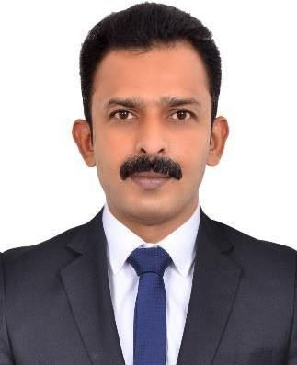Suhaim Pambara

# Dubai-UAE

**Mobile No:0563621005** [**suhaimp@gmail.com**](mailto:suhaimp@gmail.com)

**OBJECTIVE**

*To develop my career and work efficiently and effectively with a progressive organization, Challenging my skills and knowledge acquired through my education and work experience*

**Computer Skills**

Academic experiences

* Operating Systems: Windows
* Publishing and Presentation: Microsoft Office.

**JOB RESPONSIBILITY**

**Van Sales Man**

* + Successfully managed a designated sales route, consistently meeting or exceeding monthly sales targets.
  + Developed strong product knowledge, effectively explaining features and benefits to customers, resulting in increased customer satisfaction and loyalty.
  + Implemented innovative sales strategies, leading to increase in sales within the first quarter.
  + Maintained accurate and up-to-date records of sales activities, customer interactions, and orders.
  + Implement assigned tasks and programs
  + Collaborated with the marketing team to identify market trends and customer preferences, enabling more targeted sales efforts.
  + Managed inventory levels in the sales van, ensuring availability of products and preventing stockouts.
  + Resolved customer complaints and concerns promptly, maintaining a high level of professionalism and customer satisfaction.
  + Built and nurtured long-term relationships with key accounts, resulting in repeat business

and referrals.

**Sales Route Planning**

* + Strategically planned daily sales routes to optimize time and mileage, ensuring maximum coverage and efficiency.
  + Utilized GPS and route planning tools to minimize travel time and improve overall productivity.

**Customer RelationShip Management**

* + Developed strong rapport with clients through regular visits and excellent communication skills.
  + Listened to customer feedback and conveyed valuable insights to the sales and marketing teams for product improvements and innovation.
  + Provided personalized attention to each customer, tailoring solutions to their specific needs.

# Experience & Job Profile

**Organization : Danex LLC**

# Job Title : Van Sales Man

**Country / Region : Dubai/ UAE**

# Period : 01/10/2021 to T i l l S p a m

**Organization : Qatar Multitech**

# Job Title : Sales Executive

**Country / Region : Qatar/ Doha**

# Period : 01/12/2018 to 10/12/2020

**Organization : JJ Associates**

# Job Title : Sales Executive

**Country / Region : Qatar / Doha**

# Period : 01/06/2014 to 01/10/2016

**Academic Details**

# High School : Secondary School Leaving Certificate

School : Bethany ST Johns English Medium School

Year : 1998

# Pre-Degree : Science

School : Sree Kerala Varma College

Year : 2000

# BA : History

College : Vivekananda College

Year : 2003

|  |  |  |
| --- | --- | --- |
| **Languages** |  |  |
| English | Hindi | Malayalam |
| Fluent | Fluent | Mother tongue |

# Skillsets and Hobbies

* Familiar with MS Word, MS Excel, MS Power Point, Windows XP
* Hobbies : Music, Photography and Traveling

# Personal Strength

* Good Communication and Inter-personal skills
* Execute the delegated tasks
* Handles & tackle any situation
* Adapt changes & will power
* Quick learner and result oriented.
* Hardworking, energetic and sincere.
* Dedicated and self-reliant

# Personal Profile

* Father’s Name : Pambara Pareed Saithu Muhammed
* Date of Birth : 29 April 1980
* Marital Status : Married
* Religion : Islam
* Nationality : Indian
* Passport Number : T8867565
* Date & Place of Issue : 28 August 2019 at Cochin, India
* Driving License : Valid UAE & Qatar Manual License
* Visa Status : Residence Visa Transferable

# Additional Information

Interests: I enjoy strength training, travelling and reading, especially technical manuals. References: Available On Request