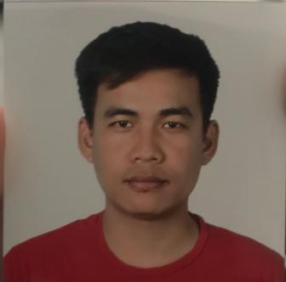

**RESUME**

YOGESH RAI

EMAIL - [yrai72@gmail.com](mailto:yrai72@gmail.com)

M - 0569887382

AJMAN

**PROFESSION SUMMARY**

RESPONSIABLE AND HARD WORKING MERCHANDISER IN PHYSICAL DEMANDING AND AS WELL AS IN CHALLENGING WORK ENVIROMENT TO ACHIVE DAILY GOALS.

**WORK EXPERIENCE**

MERCHANDISER IN TRANSMED (NON FOOD)FROM APRIL 2018 TO SEPTEMBER 2019,CARREFOUR HYPERMARKET (AJMAN,SHARJAH,MOE,WAFI), TRANSMED FOOD FROM OCTOBER 2019 ACTIVE.(LULU,NESTO,SHARJAH COOP,RAMEZ,MEGA MALL,CARREFOUR ZAIHA.

* ENSURE IN DAILY BASIS TO CHECK JOURNEY PLAN FOR EASY COMMUTING TO RESPECTIVE CLINTS.
* ENSURE TO CHECK OUR MERCHANDISE ARE VISIBLE,CLEAN,GOOD CONDITION AND IN CORRECT SOS AS PER AGGREMENT.
* ENSURE TO REFILL OUR MERCHANDISE FULLY USING FIFO GUIDE TO PREVENT EXPIRY.
* ENSURE TO ORDER MERCHANDISE WHICH ARE LESS IN QUANTITY AND OUT OF STOCK IN CORRECT QUANTITY ENSURING STOCK SHOULD AVAILABLE TILL NEXT DELIVERY.
* ENSURE TO CHECK THE DAILY INITIATIVE,AND IF COMPLETE BEFORE LEAVING.

**EDUCATION**

HIGH SCHOOL (NIOS)

**LANGUAGES**

HINDI,ENGLISH,NEPALI,BENGALI.