Zaman sami
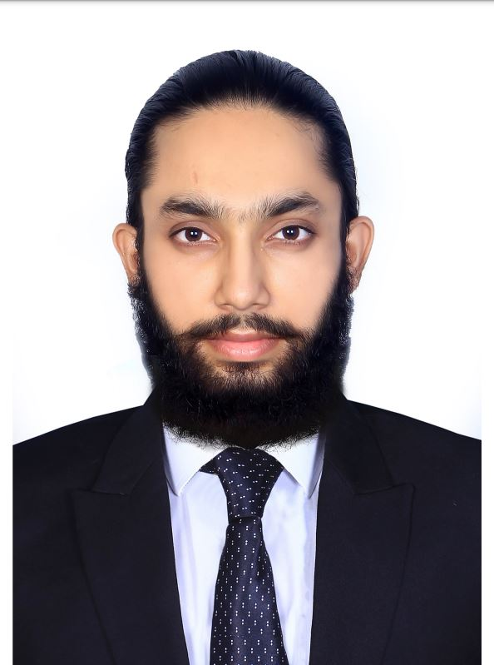
E-mail : sanyface@gmail.com
Phone : 92-321-3704521

Address: House # 164,, Sec. 8/L, orangi Town Karachi,Pakistan

Objective

To work with great efficiency with a company that gives me the opportunity to show my skills, strengths & abilities where I will work with flexibilities & full interest in work to give my best performance for the benefits of the company.

Work experience

Saima.B 2018 To 2022  Digitizing embroidery Designer (Digitizing)  Sector 12 Orangi Town (karachi)  Seeing (yawer fashion) (Digitizing) | 2018 To 2020
Digitizing embroidery designer
Dubai near Factory Mart (Ajman)
HMS Embroidery (Present) | 2020 To 2024
Digitizing embroidery designer
Banarsi cloth market Orangi town (karachi)
Seeing (NP Creation) (Present) | 2017 To 2024
Digitizing embroidery designer
Site Area near Binoria (karachi)  Saniya Mini Mart Cash Counter  Banarsi market Orangi town (karachi) | 2016 To 2017

Certification

Title Institute Year
H.S.C EXAMINATION | The city college, Karachi | 2018
S.S.C EXAMINATION | Al-Faisal secondary school | 2016
COMPUTER PROGRAM | Arena multimedia | 2017

Digitizing embroidery designing HomeTown Studio | 2022

Education

Intermediate | 2016 — 2018

The city college, Karachi

Engineering

Matriculation | 2010 — 2016
Al-Faisal secondary school
Computer Science
Computer Designing | 2016 — 2017
Arena multimedia
Photoshop
Illustrator
Digitizing Wilcom embroidery E2+E4
Digitizing embroidery designing | 2018 — 2024
HomeTown

Wilcom

Photoshop

Illustrator

Embroidery and Design Punching/Digitizing

Checking Embroidery Quality

Interests

Punctual, Hard Working and Optimistic.

Sketching, Market Survey, Listening to music and Exploring myself.

References

Will be provided on request.

2

